Company Manual of Standard Operating Procedures

Prepared for
Midnight Breeze Microbusiness
Cultivation, Manufacturing, Distribution Operations

By
Begreenlegal, LLC (need logo)
DRAFT

Table of Contents
- Welcome to the Company
- Company Structure & Organization
- Overview of Operations and Required Regulations/Approvals
- Facility Layout & Operations Flow
- Operations
- Cultivation Overview & Process Map
- Propagation
- Policy
- Workflow (Flowchart)
- Procedure
- Checklist
- Vegetation
- Policy
- Procedure
- Workflow (Flowchart)
- Checklist
- Flowering
- Policy
- Procedure
- Workflow (Flowchart)
- Checklist
- Harvesting
- Policy
- Procedure
- Workflow (Flowchart)
- Checklist
- Processing
- Policy
- Procedure
- Workflow (Flowchart)
- Checklist
- Transfer to Distributor
- Policy
- Procedure
- Workflow (Flowchart)
- Checklist
- Manufacturing Overview & Process Map
- Intake
- Policy
- Procedure
- Workflow (Flowchart)
- Checklist
- Extraction
- Policy
- Procedure
- Workflow (Flowchart)
- Checklist
- Post-Extraction
- Policy
- Procedure
- Workflow (Flowchart)
- Checklist
- Infusion
- Policy
- Procedure
- Workflow (Flowchart)
- Checklist
- Packaging
- Policy
- Procedure
- Workflow (Flowchart)
- Checklist
- Transport to Distributor
- Policy
- Procedure
- Workflow (Flowchart)
- Checklist
- Distribution
- Pick-up Transport
- Policy
- Procedure
- Workflow (Flowchart)
- Checklist
- Receiving
- Policy
- Procedure
- Workflow (Flowchart)
- Checklist
- Packaging (Non-Manufactured Cannabis Only)
- Policy
- Procedure
- Workflow (Flowchart)
- Checklist
- Testing Lab Engagement
- Policy
- Procedure
- Workflow (Flowchart)
- Checklist
- Shipping
- Policy
- Procedure
- Workflow (Flowchart)
- Checklist
- Delivery Transport
- Policy
- Procedure
- Workflow (Flowchart)
- Checklist
- Quality Control Overview & Process Map
- Policy
- Procedure
- Workflow (Flowchart)
- Checklist(s)
- Inventory Control Overview & Process Map
- Policy
- Procedure
- Workflow (Flowchart)
- Checklist(s)
- Security Overview & Security/Premises Diagram(s)
- Policy
- Procedure
- Workflow (Flowchart)
- Checklist(s)
- Safety Overview & Process Map
- Policy
- Procedure
- Workflow (Flowchart)
- Checklist(s)

Welcome to the Company!
Welcome to Midnight Breeze, a Conscientious Microbusiness built to help support and maintain connections and relationships amongst licensees in the cannabis community. Midnight Breeze Microbusiness supports the operations of three separate cannabis licenses under one roof. As employees of Midnight Breeze, you may be cross trained throughout different areas of the facility depending upon your expertise and the role(s) you were hired to fulfill.
Midnight Breeze is passionate about running a thoughtfully planned out operation which supports the comfort, health and safety of its employees while observing all the state and local regulations created around activities we engage in every day. In fact, we have carefully laid out this manual to provide you with a clear understanding of each and every process undertaken at our facility. It is important to follow all policies, procedures and workflows exactly as they are laid out because they have been designed to comply with regulations that directly impact our state licensure.
To help you better understand how our company operates, we have prepared a company structure and organization section that immediately follows this welcome letter. This section will give you a clear picture of all of the people involved in the company above your immediate department or manager. The summary and Job Descriptions provided will give you clearly defined guidelines around the role you play at Midnight Breeze, and will also help you understand what to expect from coworkers and other employees and departments of the facility.
While it may seem extensive, this manual has been designed to act as a guidebook which will help you understand exactly what the company, state and local governments expect from you as a cannabis industry worker. It will also provide maps that show the path of operations and also security features of the Midnight Breeze facility. Most importantly, this manual will help you maintain a compliant workflow that supports the integrity of the company and its state licenses.
Once you have reviewed the company organization and your related job description(s), you will be taken through some facility diagrams so that you can visually understand the facility, before diving into the licensed operations. Workflows and checklists are provided for each stage of the operations process, please refer to Section 5 for more detailed information about the processes, policies and procedures related to that stage. Please direct all questions or suggestions to your supervisor, who will also assist you with understanding the manual and utilizing the procedures and checklists provided.
We are happy to begin a professional relationship with you and look forward to working with you for many years to come!

___________________________________
Avshalom Cohen
Company Structure & Organization
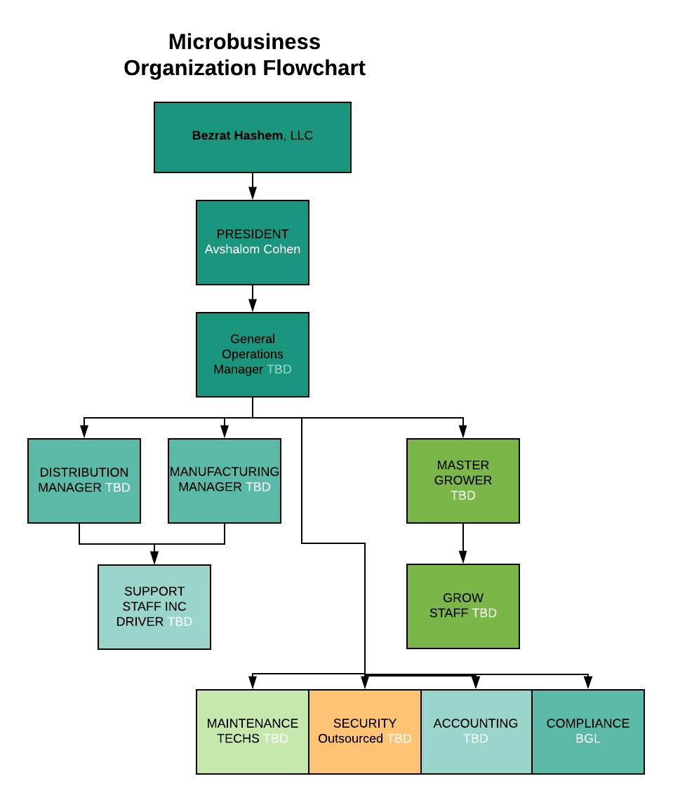
Senior Executives and Management
President: The president/CEO will establish short and long-term goals, plans and strategies for the company. Through excellent leadership and decision-making, the president will preside over the workforce, budget management and ensuring proper allocation of resources as well as ensuring all departments meet their goals.
General Manager (GM): The General Manager will oversee all department managers and their employees, implementing a company culture that supports the mission and directives of the President and collective company goals. The General Manager will also be responsible for development and implementation of policies and procedures, as well as the review process for Standard Operating Procedures (SOPs), record-keeping, inventory and all other maintenance and compliance operations. The GM will create and maintain budgets under the direction of the President and will facilitate the implementation of those budgets throughout the various departments with each department head. Additionally, this manager will also oversee the routine evaluation of employees, company performance, and deficiencies/efficiencies throughout the facility.
Mid-Level Supervisors
Distribution & Inventory Manager: This manager will oversee the distribution component of the facility. They will select other licensees from which to purchase product and will work in conjunction with company officers regarding purchasing in alignment with company goals and market trends. This person will oversee all aspects of distribution and transfer of items from the distribution component to other areas of the facility as well as managing and overseeing the accurate and consistent recording of all movement of inventory through both the company POS and state Track and Trace system. This manager may train and designate other employees to enter and track inventory and will be responsible for regular audits and reconciliation of all inventory.
Manufacturing Manager: The manufacturing manager will oversee the operations of the manufacturing facility including working with company officers to determine types and quantities as well as schedules of production. They will oversee all manufacturing staff and schedules as well as manage and designate staff to manage the input into the state track and trace system of the movement of all cannabis material and finished products through the production phase. Managers will ensure the accurate and consistent completion of all forms, checklists and procedures, including appropriate chain of custody forms for all movement of cannabis and cannabis products through phases of production.
Master Grower: The master grower will oversee the development and implementation of cultivation operations at the facility. Duties will include selecting and sourcing cannabis strains that meet the goals set by the President and company officers. The Master Grower will develop cultivation plans, and oversee cloning, transplanting and the provision of nutrients for selected strains of marijuana plants. These duties include setting up and maintaining irrigation systems and environmental controls, as well as ensuring that the facility is pest free. Midnight Breeze will require that its Master Grower has experience operating at least 10,000 square feet with multiple indoor rooms. The exhausting list of duties of the Master Grower are highlighted by the following:
- Knowing and selecting which strains we will grow, preferably with input from our customers
- Running the nursery program, including the health and rotation of our mother plants
- Scheduling and planning of the vegetative process and inventory
- Controlling all grow room lighting, climate controls, ventilation, and maintenance
- Ensuring flower rooms stay on schedule
- Determining corrective actions for defects or contaminants
- Pinpointing proper harvest times and treatment of plants; and
- Identifying areas of improvement based on empirical data as well as past experience
Compliance Manager: The Compliance Manager will be responsible for ensuring that company policies and procedures comply with regulatory and ethical standards from both state and local governments as well as the Business & Professions and other relevant codes. The Compliance manager will oversee the performance of regular compliance audits as well as the development and implementation of company policies, procedures, and design control systems. The compliance manager will be supervised by the Virtual Compliance Officer Chris Cox.

Entry Level Team Members
Transport Drivers: Drivers of the company will retrieve orders from the delivery area following specific company policies and procedures and deliver them to end user retail customers under the direction of the Distribution Manager.
Manufacturing Support Staff: Manufacturing support staff will work under the direction of the manufacturing manager and will carefully follow all company standards, policies and procedures to carry out the production and packaging of manufacturing outputs at the facility.
Grow Staff: Grow staff will work under the direction of the Master Grower to carry out all tasks required to successfully grow, harvest, trim and pack cultivated cannabis flower for use in the facility manufacturing, distribution and retail components. The grow staff team will spend most of their shifts tending to the plants and will painstakingly follow to the letter all company SOPs with Key Performance Indicators (KPIs) being measured and provided to both the Master Grower and Operations Manager for a prompt, professional response.
Maintenance: These personnel will work throughout the facility in a variety of capacities under the supervision of the facility managers to keep equipment, the building and the facility grounds clean and in good working order. Staff will follow set policies and procedures to perform all maintenance duties at the facility. As contamination and pest prevention is a cultivation killer, facility maintenance techs will play a very important role in the Midnight Breeze operation. This position may be combined with one or more other positions, such as master grower, grow staff, etc. Managers will track their performance to ensure compliance with our SOPs.
Security (Outsourced): Security personnel required for the retail premises of the facility and other security required or desired by the facility management will be outsourced from a California Licensed security firm who will work closely with the managers and officers of the facility to perform duties related to patrolling, guarding, analyzing and monitoring the facility.
IT & Accounting Support: IT and accounting staff will work in each separate premises of the facility to provide support for the technological systems including POS and Track and trace and any other inventory control systems utilized at the facility as well as inventory oversight, reconciliation, audits and assistance with stocking and ordering products.

Overview of Operations & Required Regulations/Approvals
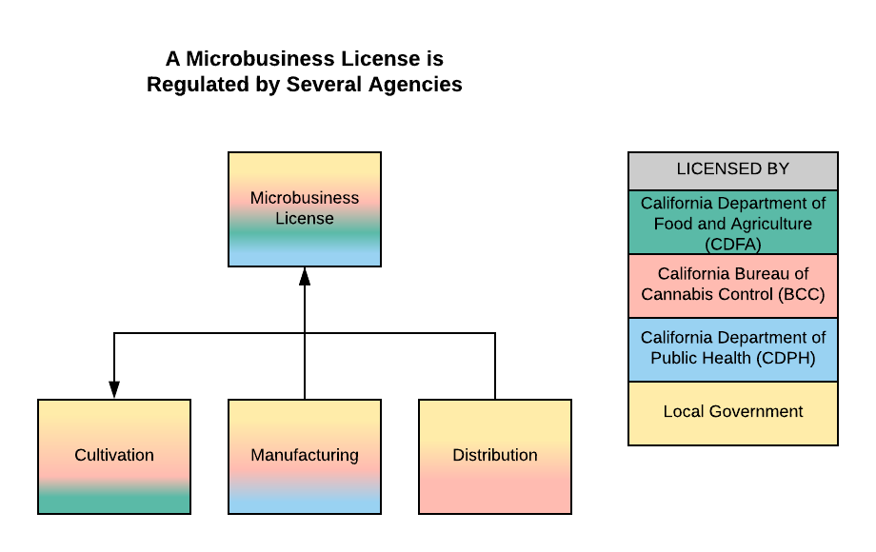

State of California Cannabis Licensing
Midnight Breeze is currently applying for three cannabis licenses from the State of California, including an Indoor Cultivation License, a Type 6 Non-volatile Manufacturing License, and a Type 11 Distribution License. As state licensees, Midnight Breeze, LLC pledges to perform all operations activities, as well as any other designations and privileges allowed to such licensees in strict accordance with all local and state regulations governing these cannabis licenses, which include:
- Periodic inspections by state regulators;
- Recordkeeping audits and reporting;
- Annual state license renewals;
- Compliance with required standard operating procedures (SOP)s
- Establishment and implementation of required protocols; and
- Responsibility for all employees, including:
  - Employee actions while on the premises of our proposed facility,
  - Regular training for continued education, safety, and compliance; and
  - Enrollment with the Employment Development Department. Licensing Maintenance
Midnight Breeze, LLC will comply with annual renewal requirements. A state cannabis licensee must submit an annual renewal to remain active. Licensees are also subject to unscheduled inspections and compliance with state requirements for standard operating procedures (SOP).

Labor Peace Agreement
As a function of its state licensing obligations, Midnight Breeze, LLC will execute a Notice of intent to enter into a Labor Peace Agreement. If the facility employs over 20 employees, a Labor Peace Agreement will be put in place with a local Union.

Operations Overview

Day-to-Day Distribution Division
Our distribution operation will likewise follow suit with our robust, compliance-based cultivation business. Whether we are focusing on self-distribution, as described above during our first phase of operations, or have expanded to include distribution of products from third-party cultivators and manufacturers, we plan to operate in compliance with all local and state-required protocols and procedures.
The flow chart below describes the steps we plan to incorporate into our distribution operation, which follows state regulations issued by the Bureau of Cannabis Control:

Flow Chart 4 - Distribution Workflow
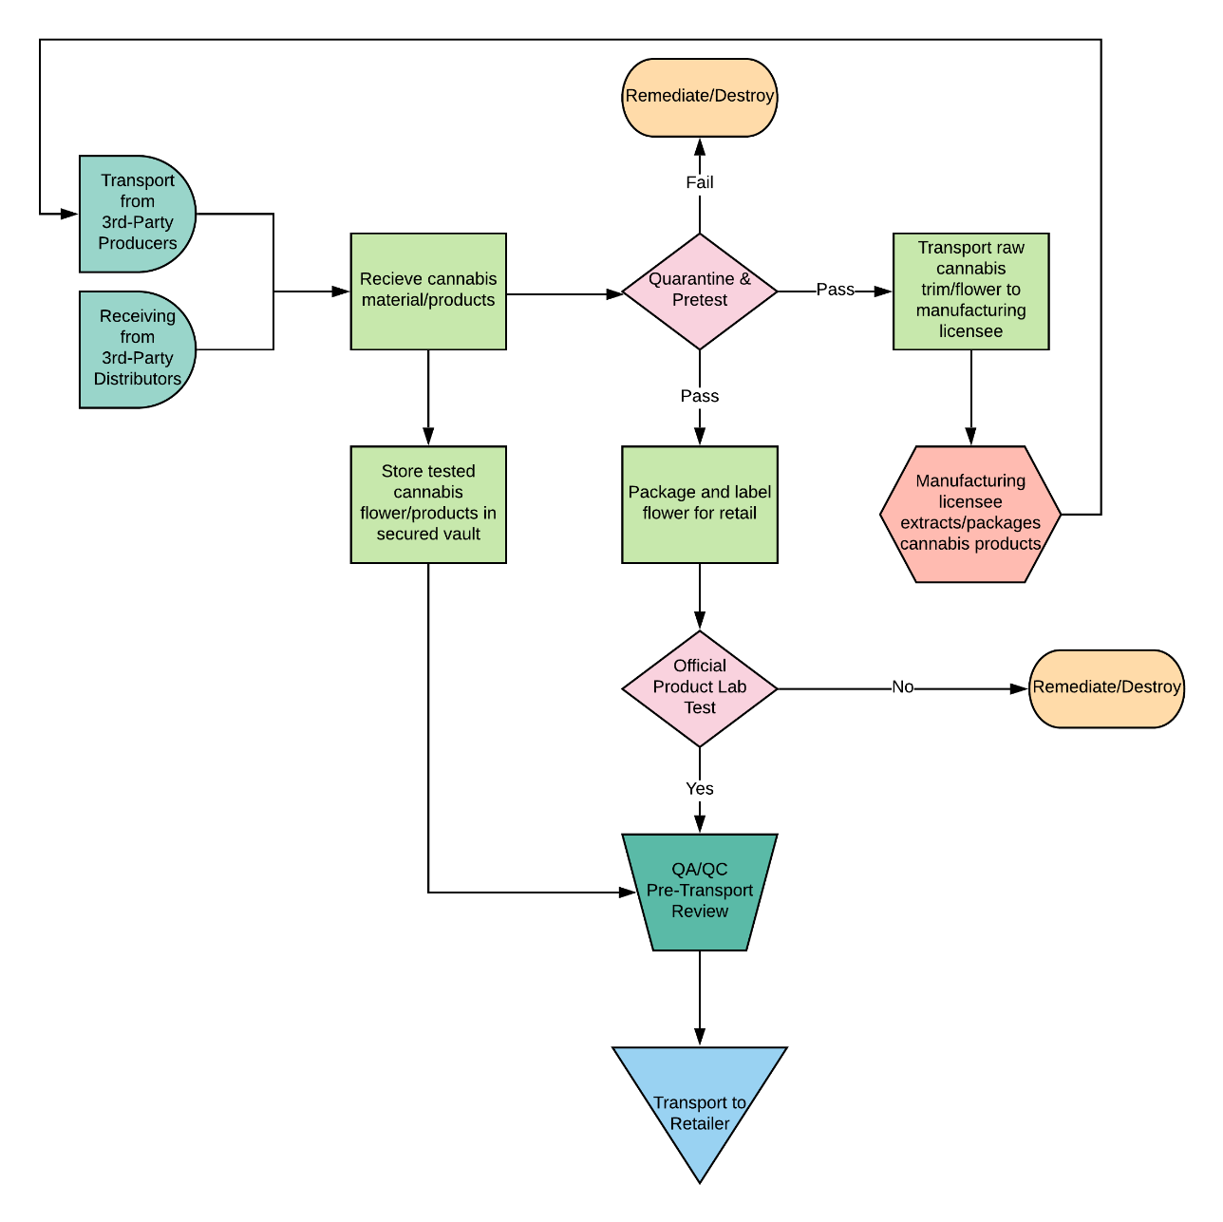

Step 1: Receive Cannabis Products
We anticipate receiving products to our distribution premises in one of two ways; either from our own cultivation operation via our cannabis storage, or from third-party cultivators and manufacturers who will either interact with our transporter at their location or drive their products to our distribution operation. All incoming cannabis materials of any kind will be associated with a Chain of Custody (COC) form and manifest.
Step 2: Testing
Incoming products will be placed in quarantine storage to await testing. A testing laboratory will be engaged and will send a testing representative to our facility to collect samples of products to be tested. Upon arrival, the testing representative will be accompanied by our distribution representative to our testing room. Products to be tested will be transported from our secured vault to the testing room, after which the testing representative will select sample increments from each cannabis flower or cannabis product batch. Batch sizes are defined in state regulations and not to exceed 50 pounds of flower or 150,000 units of manufactured products. Our distribution representative will observe the testing procedure in the testing room and recorded on camera with a time-date stamp as required by state regulations.
Once the testing representative has collected, bagged, sealed, and recorded those samples slated for testing, our distribution representative will escort the testing representative from the building. We will then await our certificate of analysis (COA), which will tell us whether the products have passed testing.
Step 3-4: Transport to Tested Cannabis Storage
Upon receiving the COA for a particular product, our staff will transport the batch associated with the test identification number to our designated vault for tested cannabis products. The products will then wait in this vault until we are ready to package for the retail market. If stored products are manufactured cannabis products, we will alert our sales team of the added inventory and market to our retailer network. If stored products are cannabis flowers, our packaging staff will prepare these products in retail-ready packaging and state-compliant labeling, including those testing results obtained in the COA. We will then store these products in our tested cannabis vault(s) to await transport to a retailer.
Step 5-8: Transport to Retailer
Once our sales team has selected a retailer for a wholesale product, it will be transported via our secured transport vehicle through the shipping and receiving area in the rear of our cultivation operation. Transport out of the warehouse will take place in the same way as for Step 9 in Section 5e.
Once en-route, our employees, transport driver and passenger assistant, will drive to those destinations designated on the transport manifest for a delivery. Transporters will not make any other stops along the way and will proceed directly to the destination. A GPS tracking device will be installed either temporarily or permanently at all times and will broadcast a signal indicating the location of the vehicle.
Our transport drivers will deliver those deliveries designated in the transport documents to licensed retailers. In addition to our insurance, we will require that our retailer customers have insurance covering deliveries to their premises and have a security guard onsite and within view at the time of the delivery. Once products are transferred from our vehicle to the licensed retailer premises, we will record the transaction in the chain of custody and transport manifest documents. We will then collect payment if the transaction is in cash or complete the bill of sale in a manner authorized by our management.
Step 9: Post-Delivery
Once delivery of a product is completed, our drivers will return to our facility to complete paperwork and close out the transaction. We will also record and transfer any money required for cultivation or excise taxes to the Department of Tax and Fee Administration as necessary according to the Agency’s due dates. Last, we will ensure that the transaction was recorded properly, and all documents have been stored.
Waste Management Procedures
Green Waste Solutions will assist us with managing any material used or which has come into contact with cannabis during the cultivation, production, manufacturing, or retail process that must be disposed of. Examples are as follows:
- Unused or leftover marijuana
- Expired, unused, or leftover edibles
- Unused or leftover oils or extracts
- Wrappings, cartridges, or products
- Cultivation trimmings
- Cultivation Growing medium
- Used testing samples
- Harvested, used plants

Manufacturing Division
To illustrate how our operation will function, it may be helpful to use a commercial bakery as an analogy. Instead of flour, sugar, etc., our raw material is marijuana plant matter and instead of mixing the ingredients, allowing the dough to raise and then baking, cooling, packaging and delivering it to the market, we put the plant material through high pressure extraction equipment called a rosin press to process out the oils, which are then treated further to become finished products, packaged properly to protect and preserve the quality as it is tested and then transported to its final retail destination. Additionally, plant matter will also be processed through cold water extraction to produce bubble hash, which can then be further processed by high pressure extraction, infused into pre-rolls or cured and packaged on its own.
Our services will be further enhanced by providing clients with solutions to issues that are related to failing testing. By providing remediation solutions that will clean impurities out of products so that they can be sold at the retail level, we will add valuable interactions that enhance the partnership and quality control of all products we touch.
Our operations are broken into several manufacturing areas including extraction through solventless methods, and packaging which include pre-rolls and vape cartridges. We have included a few flow charts below that show our workflow.
Solventless Extraction
Our solventless extraction activities will be comprised of inspection of the raw material and then prepping the material to be extracted through ice hash or cold (rosin) pressing methods. The techs will closely monitor the equipment and collect the resulting oil, which is then carefully stored and further processed through several different proprietary curing or finishing techniques that could last up to five or six days to produce an exceptionally high-quality, consistent, safe, test-passing product.
After a batch has been completed, it is placed into a quarantine status while preliminary test results are produced by an independent, third party, state-licensed testing service. Once the product passes our preliminary tests to ensure there are no impurities, it will be packaged and labeled according to state requirements and transferred to or stored for transfer to our distribution center.
The following flowchart shows the complete step by step process for production of rosin extracts. From receipt and pre-inspection to extraction and transfer, the facility implements many measures of checks and balances to ensure the creation of a top quality product.

Flow Chart – Rosin Cannabis Extraction
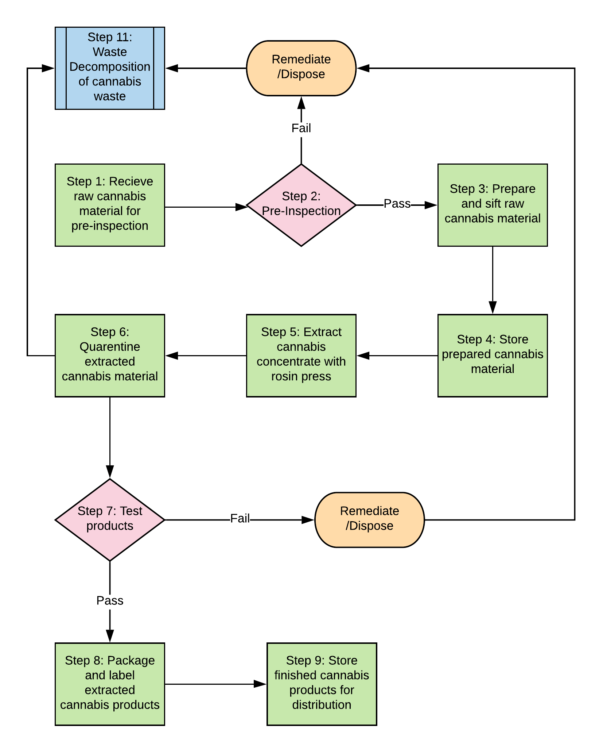
Packaging and Labeling
All packaging used by our manufacturing operation will be child resistant according to standard for “special packaging” 16 CFR 1700.1(b)(4) and will not imitate any packaging used to market products to children. Single use items will be individually sealed according to regulatory standards. Packages will be released our distribution arm in their final form in accordance with current regulations.
Remediation
Midnight Breeze is interested in establishing a remediation solution for cannabis producers interested in cleaning cultivated or manufactured products of impurities to pass testing requirements. While remediation remains a challenging activity as the state of California has not yet settled on clear procedures, there is already demand for it in the industry and we expect that demand to increase significantly as labs are scrutinized more closely and enforcement increases. The company intends to monitor the requirements and demand for this solution over the next 1-2 years and prepare for implementation as it make sense to do so.

Waste Management Procedures
Green Waste Solutions will assist us with managing any material used or which has come into contact with cannabis during the cultivation, production, manufacturing, or retail process that must be disposed of. Examples are as follows:
- Unused or leftover marijuana
- Expired, unused, or leftover edibles
- Unused or leftover oils or extracts
- Wrappings, cartridges, or products
- Cultivation trimmings
- Cultivation Growing medium
- Used testing samples
- Harvested, used plants

Cultivation Division
Midnight Breeze will be held accountable by the City of Long Beach, the State of California and by our clients to produce safe, and compliant cannabis flower reliably and consistently. Midnight Breeze products will be pre-tested twice before cultivation crops are complete, and again through formal testing via the in-house distribution operation before entering the medical retail market.
It is therefore vitally important that the company has an efficient and highly standardized set of processes and procedures, which will be flushed out and consistently improved over time with the help of internal staff and expert consultants. The company is currently developing a complete standard operating procedure (SOP) manual which will be incorporated following the finalization of build-out of the cultivation facility. A copy may be requested and will be made available once it is complete.
The Midnight Breeze team will focus heavily on the overall health and well-being of its entire inventory of plants as they move through the production cycle to make sure they remain pest and disease-free and grown in sanitary conditions. Each plant will receive water and nutrients in an amount determined by sensors to ensure the most effective application without waste and subjecting them to overwatering. The cultivation areas will use artificial light designed and programmed to mimic the most optimal growth conditions.
All of the controls and expertise in growing methods utilized by Midnight Breeze will ensure that its plants receive the proper amount of light, water, nutrients, and careful handling to fully mature on schedule while yielding the highest amounts of flower possible. Each step in this process will be documented and the results meticulously tracked to identify areas of improvement and deviations.
The concluding steps in the Midnight Breeze process will be dependent upon customer demands. Some manufacturers will prefer to take down the entire plant whole and purchase it from the company to either freeze or process in whole or part immediately, greatly relieving the workload and overhead costs. For others, staff may be asked to trim the plants, separating the more valuable and potent flower buds from the remaining, but still valuable, “trim” material, which results in far more labor but hopefully a higher return. If crops are slated for the retail flower market, they will be dried, cured, trimmed, manicured, and bulk-packaged before they are moved to the licensed distributor operation for testing and retail packaging.
As anyone that has ever toured a cannabis cultivation would likely attest, most of the daily work is spent in Steps 4 and 6 on the flowchart below, which involves watering and caring for the plants during veg and flowering growth stages. Midnight Breeze expects that its dedicated team of people will arrive at the facility early in the morning, likely 6 to 7am depending on the artificial lighting schedule that may be in place, to begin tending to the crops and leaving in the evening to complete a normal workday. Cultivation operations may involve two shifts to maximize productivity.
Flow Chart - Cultivation Workflow
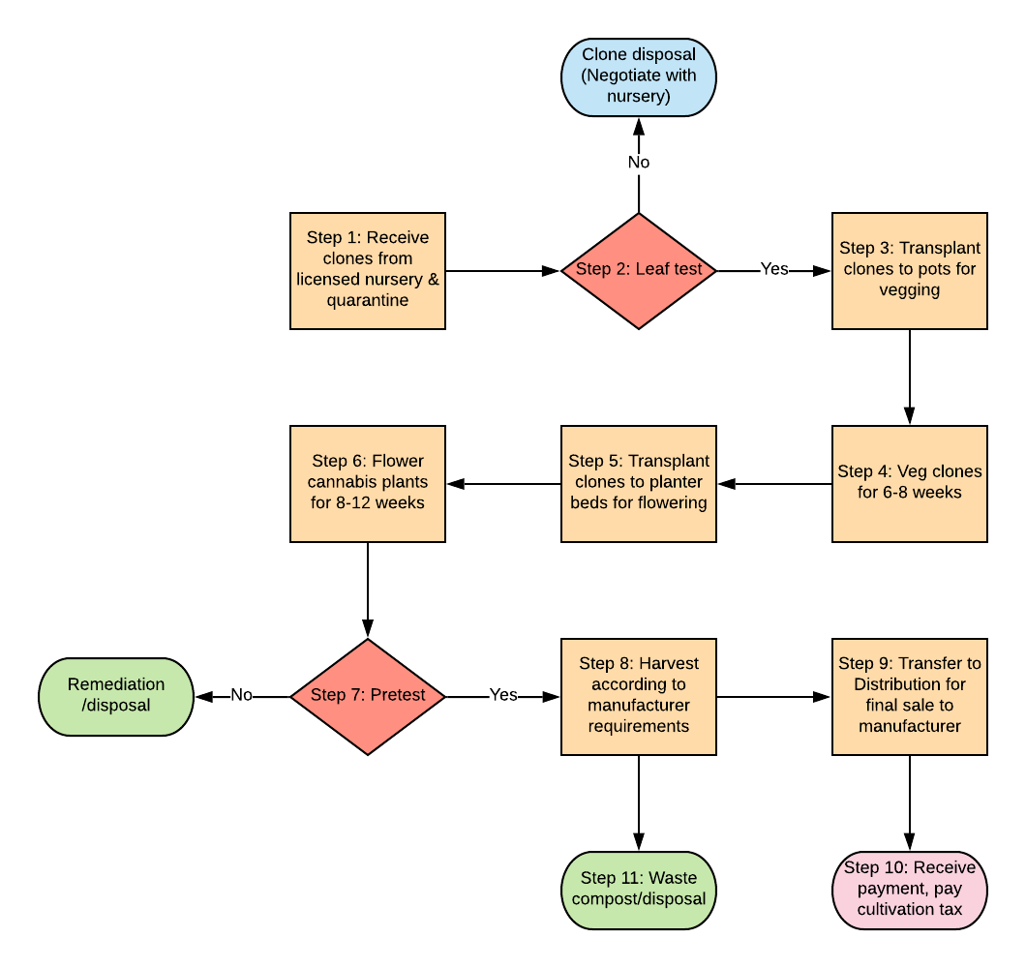
Step 1: Propagate or Receive Clones
Midnight Breeze plans to propagate its own clones by growing mother plants of specific genetics from seed, and rooting cuttings in the vegging room of the cultivation facility. If the company does not have an adequate number of clones for a particular crop, it will purchase clones from a Type 4 licensed cannabis nursery. While creating its own clones will benefit the operation with reduced costs and ensure that Midnight Breeze grows the same genetics throughout successive harvests, purchasing clones will also provide benefits to the operation. First, it will be able to rely on one or more nurseries for consistent, high-quality, pest, and pesticide free clones of many different cannabis strains, depending on market demand. Second, purchasing clones eliminates the need to rely fully on an in-housing cloning operation with more limited varieties and could result in a delay in production if a crop of clones fails.
The Midnight Breeze facility will be utilizing a Netaflex 3G irrigation system to precisely control watering and nutrient dosages for all plants in the vegging and seeding areas. Clones will be taken regularly from mother plants that have been grown from seed in the seeding area identified on the premises diagram. Clones may also be taken from vegging plants as further described below. Clones will follow a growth and propagation cycle to ensure a steady supply of plants in all phases of growth.
Step 2: Quarantine and Leaf Test
Before transplanting pre-purchased clones to another phase in the vegetative areas of the facility, Midnight Breeze staff will quarantine any purchased clones and send leaf samples to a licensed cannabis testing laboratory to ensure they are free of pesticides and microbial infections.
Step 3-4: Vegetative Growth
Once staff has viable clones ready for the vegging stage of the growth cycle, they will transplant into small, starter net pots in the vegetative area of the nursery. Vegetating cannabis plants require 18-24 hours of light per day to grow at this stage. Providing less than 15 hours of light per day would prompt flower production.
The goal of vegetation is to grow the plants to a size and vitality that they will produce high-yielding flowers. Midnight Breeze plans to use double ended HPS (High Pressure Sodium) and Metal Halide (MH) lighting similar to that pictured below. Studies have shown that using the double ended vs the traditional single ended bulbs increases the efficiency of the fixtures by an additional 20% to 30% percent. Double ended MH bulbs will be used for the vegetation stages. Plants in the vegetative and pre-flower stage will be watered and provided nutrients using precise controls in the Netafim Netaflex 3G system.
Hood Grow Light Reflector with Double Ended MH Bulb

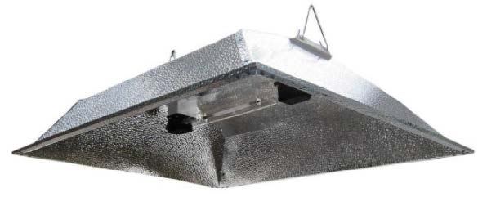
Plants will be pruned as needed to maximize the eventual yield and direct plant growth without overstress. As the vegging process typically takes about 2-4 weeks, vegging plants will be inspected and tended to as needed before being rotated into the flowering area after the previous harvest.

Step 5-6: Flowering
Once vegetating plants are ready, and the previous flowering crop has been harvested, the flowering area will be cleaned and sanitized. Vegetated plants will then be transplanting into larger net pots for the flowering stage to provide more volume for root growth and moved into the flowering areas of the vegging room. Flowering will then be implemented, which involves limiting artificial light to twelve hours per day.
During flowering, plants will be pruned and trained on plant supports to maximize the number of nodes producing cannabis flowers, much like grape vines or apple orchards are trained on trellises. The climate will be regulated through electronic controllers and sensors that detect optimum growing conditions, including humidity, temperature, and CO2 levels. Excess heat will be exhausted and cool air from the atmosphere will be drawn in as needed. All exhaust will be directed through our state-of-the-art odor control system to eliminate exterior nuisance odors.
HPS Double Ended Bulb
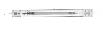
The adjacent photo depicts an HPS bulb, which looks almost identical to the MH bulb used for the vegetative stages however this HPS bulb operates on a red-orange lighting vs the blue lighting spectrum used in the MH bulbs, which assists the plants with flowering. This bulb will be utilized in the same types of fixtures as shown above for the facility’s flower production. As the company moves towards outfitting the operation with equipment, it will fine-tune the equipment list to include the best and most cost-efficient products available at that time.
Prior to, or possibly just after harvest depending on need, flower samples will be pretested for microbials, pesticides, and potency to ensure the crop is suitable for the retail market and provide feedback on optimal harvest times to maximize cannabinoid potency.
Step 7: Harvesting
During a harvest, depending on the customer requirements, staff will either cut down the plants whole and prepare them for shipment, or “buck” them down into manageable stem sections for drying and separating the flower buds from the plant trim, both of which contain valuable compounds for cannabis concentrates and oils.
If the Company is preparing cannabis to be sold as flower through its in-house distribution channel, Steps 8 and 9 will require a lot of trim labor, as well as packaging, based on the finished product state. If the harvest is slated for manufacturing of cannabis concentrates, Midnight Breeze will abide by the specifications of its manufacturing department or licensed partners, as they may want to purchase the entire plant or have other requirements for harvesting and curing.
Step 8: Drying, Curing, Trimming, and Packaging
If a harvested crop is not immediately sold and transported to the Midnight Breeze or other licensed cannabis manufacturer, the cannabis flower will be dried and cured in the designated drying room for approximately 7-14 days. Drying will begin with robust ventilation to quickly remove excess moisture over the first 72 hours, after which ventilation will be slowly reduced as needed to prevent the product from drying out too quickly. Once the product is deemed to be adequately cured, with enough time and climate controls to mature the cannabinoids, the grow team will trim and manicure the flowers while separating trim material. Cannabis waste in the form of stems and water leaves will be set aside for composting and disposal. Finished flowers and trim materials will be packaged in bulk, wholesale packaging, and then stored in a secured storage vault to await transport to the inhouse distribution or another licensed distributor.
Step 9: Transport
Cannabis products grown at the facility will be processed through the in-house distribution channel for testing, packaging, labeling and distribution either to the in-house retail or manufacturing facilities or offsite to another licensed distributor, retailer, or manufacturer.
Step 10: Waste Management and Disposal
The last step in our cultivation process will involve the removal of cannabis waste. We will be partnering with Green Waste Solutions, bringing a high level of efficient transport recycling services to handle all aspects of our cannabis facility. Waste will be collected to a pre-determined level, such as filling a certain number of locking bins with cannabis waste, which will trigger the scheduling of a Green Waste service pickup. Green Waste is licensed to handle cannabis waste and will follow all chain of custody and track and trace procedures.
Standard Operating Procedures
During the entire process, waste management, sanitation, and safety are a priority every day. Throughout all these steps and stages, Midnight Breeze staff will accurately record all transitions and dispositions of each plant in the seed-to-sale inventory tracking system according to company policy in both a written and digital manner, as further detailed in this company Standard Operating Procedures Manual. Midnight Breeze compliance protocol will also alert managers to any discrepancy in real time to enable the team to take corrective action as required.
During parts of most days, training and teaching newer members of the staff will occur with the Master Grower, who him/herself will be spending parts of every day staying up to date on the latest findings, trends, and technologies available to a cultivator of our size and focus.

Facility Layout & Operations Flow
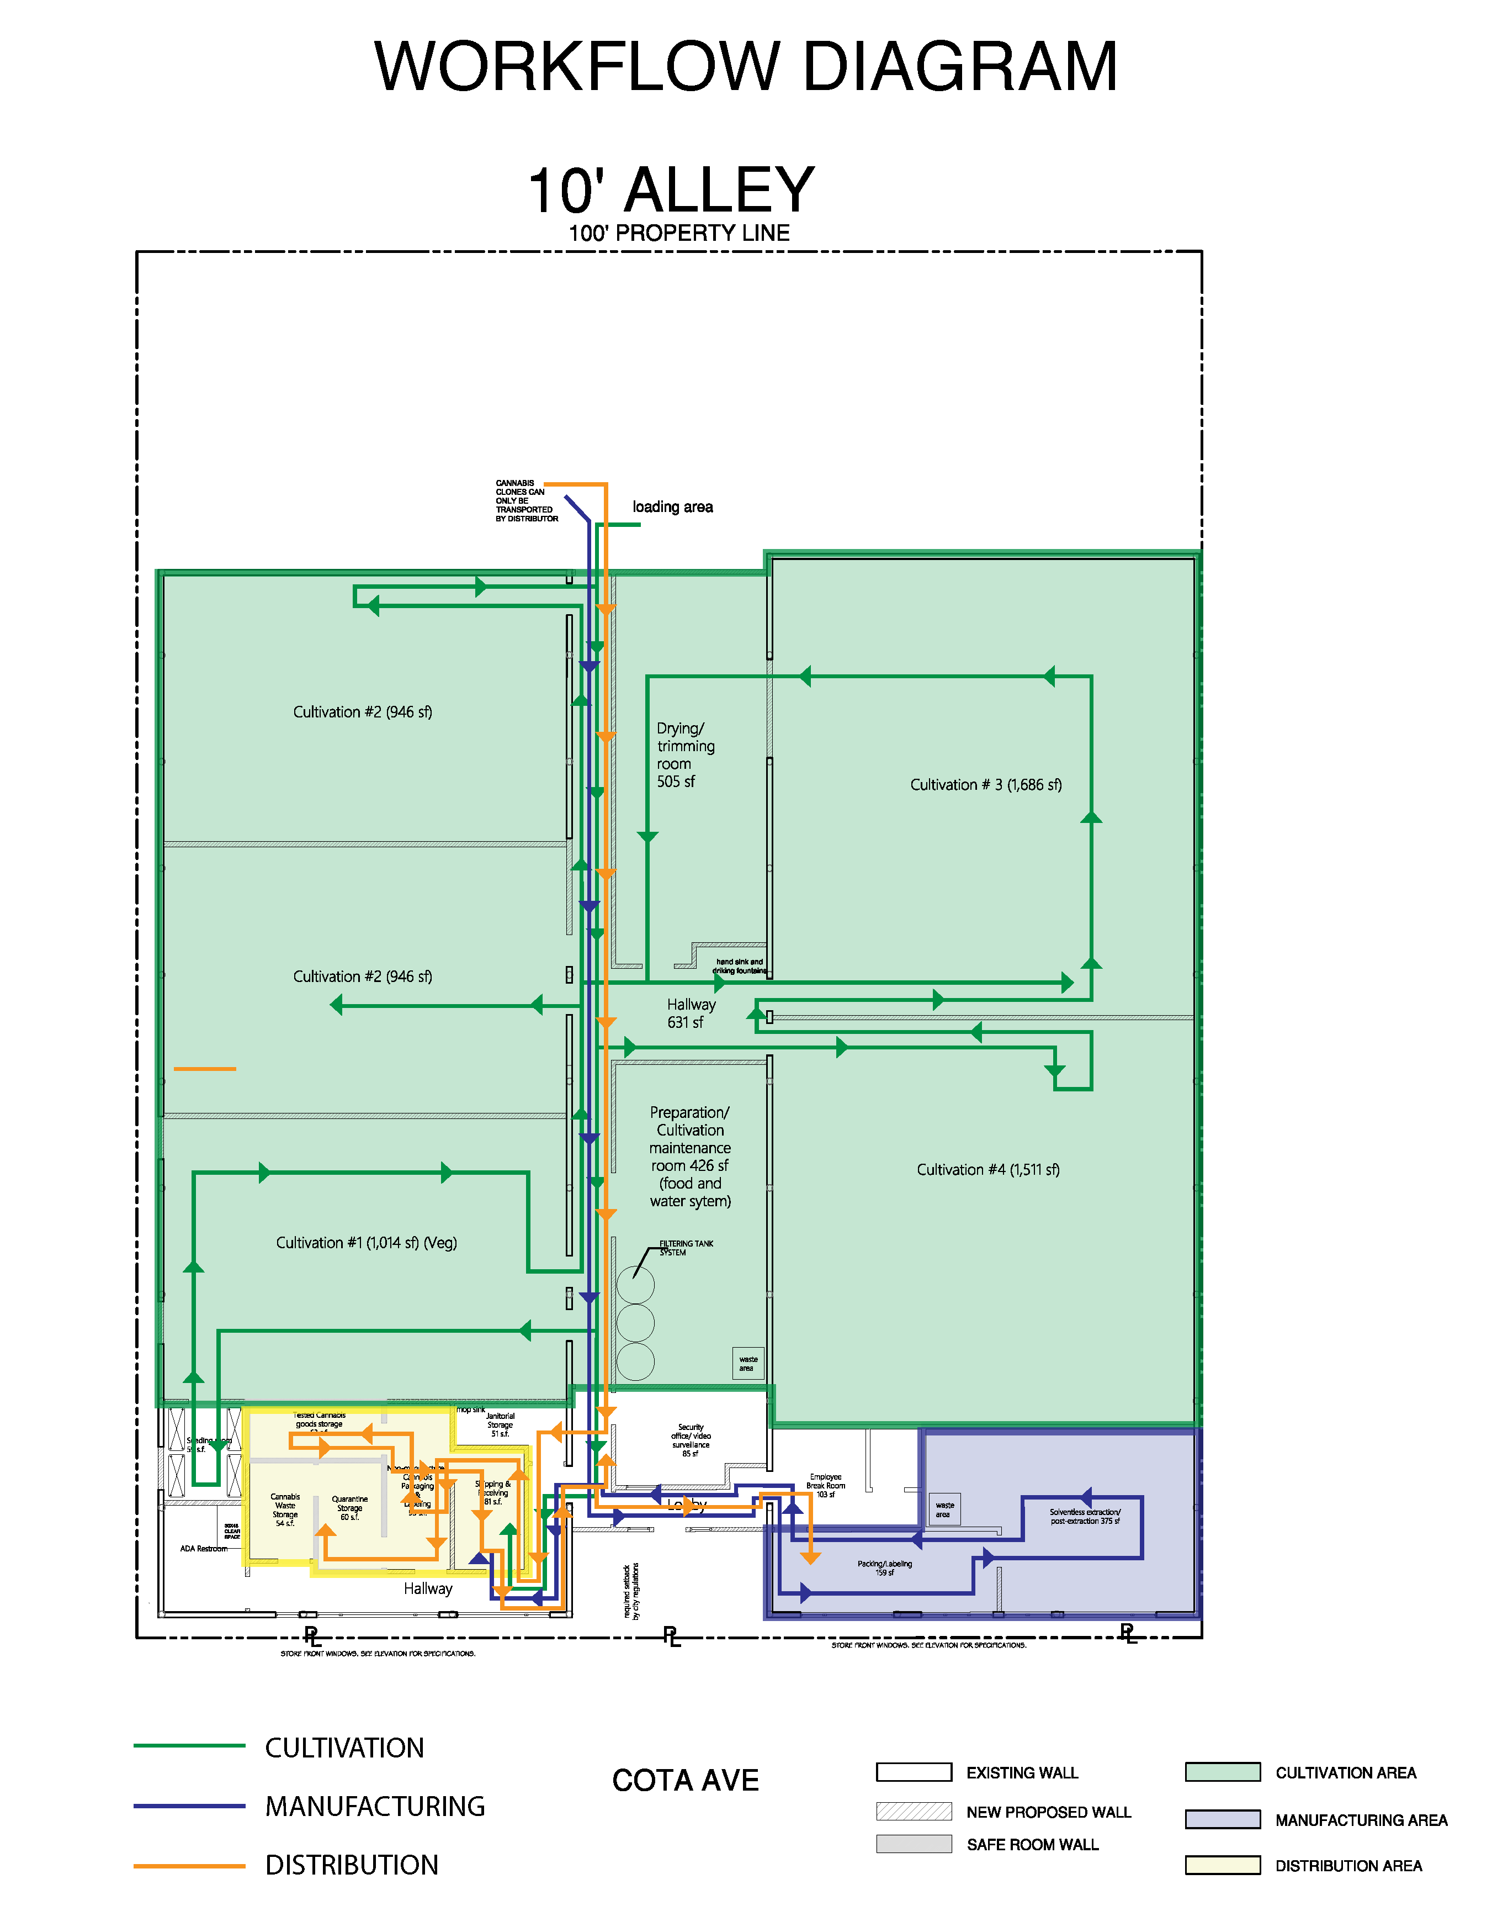

Cultivation Operations
The Cultivation area of the facility is depicted in the green section in the diagram above.
- Receiving: Products for cultivation will be received in the secure loading area at the rear of the facility. Vendors will be verified and logged by security trained staff upon entry.
- Propagation: The seeding room has been designated as the area where plants will be seeded and then moved to the vegetation area of the facility. The seeding room is located at the back of the cultivation facility, abutting the Cannabis Waste Storage and Tested Cannabis Goods demising walls of the Distribution premises.
- Vegetation: The seeding room opens out to Cultivation Room #1, which has been designated as the Vegetation Room. Plants will be held in the Vegetation Room throughout all stages of vegging and flowering before they are transferred to the other cultivation areas for harvesting trimming and curing activities.
- Flowering: Plants will be transferred to Cultivation Rooms #2, #3, #4 & #5 for progressive phases of harvesting, trimming and curing.
- Harvesting: All cultivation rooms (#2-5) will be used as a drying room after their own harvest. Rooms #2 and #3 are located directly adjacent to the vegging room, while rooms #4 and #5 are located across the hallway.
- Processing: Drying and Trimming will occur in each of the cultivation rooms post-harvest. Products will be bulk packaged and labeled in this room and stored until transport.
- Transfer to Distribution: Products may be stored in a designated area of the Drying/Trimming room until they are ready to be transferred to distribution. If the harvest is too large for the designated storage in the room, product may also be stored in the additional cultivation rooms or the drying/trimming room as needed. All products will be meticulously tracked in the state Track and Trace system as they move from area to area.

Manufacturing Operations Workflow
The Manufacturing area of the facility is depicted in the grey section in the diagram above.
- Intake: Bulk oils and concentrates received from outside vendors will arrive at the secure loading area at the rear of the facility where they will be met by Manufacturing staff in the parking/unloading area. Items will be completely processed and verified prior to being hand carried through the main corridor of the facility into the Packing/Labeling area of the facility for processing.
- Pre-processing: New inventory will be recorded and processed for its intended use in the Packing/Labeling area of the facility. A designated storage area will be located in this room to store products until they are ready for extraction.
- Extraction: Prepared product will be processed through either pressurized mechanical extraction or ice water processing in the designated solventless extraction/post-extraction room.
- Post-Extraction: Extracted materials will be temporarily stored for further processing and curing in the solventless extraction/post extraction space. A waste area has been designated in this space as well to handle any waste produced by extraction and post-extraction activities.
- Infusion: At this facility, infusion activities will include infusing hash or concentrate with bulk flower. All Infusion activities will occur in the Packing/Labeling area. Infused items will be properly packaged and labeled before being recorded and placed in secure storage for transport.
- Packaging & Labeling: Bulk concentrates and oils received from outside vendors, as well as hash and rosin products produced by solventless extraction processes will be packaged and labeled in its final retail-ready packaging in the Packaging/Labeling area of the facility which is located opposite the common area breakroom.
- Transfer to Distribution: Stored and packaged products will be transferred to the in-house distribution component via hand carry from the manufacturing area, across the common area lobby and into the shipping and receiving area of distribution.

Distribution Operations Workflow
The Distribution area of the facility is depicted in the yellow section in the diagram above.
- Receiving: Items will be received from the cultivation area of the facility via hand carry by staff down the common corridor connecting distribution to the cultivation area into the Shipping and Receiving area of the Distribution facility. Manufactured products will be hand carried from the manufacturing area across the lobby into the same area of distribution for receiving.
- Pickup/Transport: Distribution staff may transport products for the facility from licensed vendors by picking up from an offsite facility and returning product to the operation. Transport staff with incoming product will park at the rear of the facility and hand carry incoming items through the shared corridor between the cultivation and distribution areas. All cultivation area rooms will be closed during the transport of any distribution products through the corridor.
Vendors may also retrieve product from the facility in this area as well. Vendors will be verified prior to scheduling pickups and will be verified once more by security-trained staff before they are allowed to enter the gated rear parking area. Vendors will park at the rear loading area of the facility where they will meet distribution staff for completion of the order.
- Receiving: All incoming items will be processed through track and trace and the company inventory system in the shipping & receiving area of the facility before being transferred to tested storage or quarantine storage.
- Packaging of non-manufactured cannabis: Non manufactured cannabis products such as bulk flower, which enter the shipping & receiving area, may be re-packaged in accordance with the needs of the facility. This activity will take place in the Non-manufactured Cannabis Packaging & Labeling area of the facility. Completed packages will be transferred to the appropriate storage area of the distribution premises.
- Testing Lab Engagement: Goods stored in the quarantine storage area will be scheduled for testing at the earliest available date after their receipt into the facility. Testing will be completed in a designated area of the Quarantine storage space.
- Shipping: Tested cannabis goods will be transferred to either the in-house manufacturing area of the facility for further processing or will be shipped to receiving vendors offsite. Orders will be transferred from tested goods storage and prepped for shipping in the Shipping & Receiving area.
- Delivery Transport: Cannabis products will be transported by distribution staff to other licensed vendors who have been previously verified and engaged as selected business partners. Shipments prepared for transport will be conveyed by hand down the corridor between distribution and cultivation operations. All cultivation areas will remain closed during conveyance of product to the rear loading area. Transport drivers will follow security procedures to secure product for transport and will exit the gate on the west side of the facility with the help of security trained staff (who will open and close the gate).

Operations

Microbusiness Operations Summary
As illustrated in the workflow diagram, the operations of the facility will work together to both encourage production and support a continued stream of inputs and outputs. This means that the distribution and transport teams are equally as valuable and important as the cultivation or manufacturing teams. Without the unique synergy created by the purposeful layering of each activity, the operation would not function at its highest efficiency. It is for this reason that we focus specifically on the activities of each aspect of our operation in this section, offering both policy and a visual and verbal procedure that will guarantee consistent and repeatable results, a hallmark of a smooth and efficient operation.
We begin with the backbone of our cannabis business, which will be staffed by a team geared specifically toward producing high quality cultivated cannabis at the facility. For the sake of this discussion we are referring to each specific activity in the facility as having a team that is uniquely oriented to produce the desired outputs of that activity. In the case of Cultivation, the team will include a Master Grower and a number of supporting cultivation staff. The Manufacturing Team will be comprised of the Manufacturing Manager and supporting staff, while the Distribution team will include the Distribution manager and supporting staff. The General Operations Manager will oversee all the managers of the facility, as well as adjunct support staff such as security, maintenance, accounting and compliance under the direction of the owner and license holder.

Cultivation Operations

CULTIVATION OPERATIONS POLICY & PROCESS MAP
It is the policy of the company that all cultivation activities performed at the facility are performed in full compliance with all applicable regulations of the California Department of Food and Agriculture and the Bureau of Cannabis Control. The Bureau of Cannabis Control regulates Microbusiness licenses that contain a cultivation component, by adhering to the existing regulations placed upon cultivation operations by the California Department of Food and Agriculture (CDFA).
This section of your manual will look at the cultivation operations through the lens of regulations applied to each of the cultivation processes carried out at your facility. The following flowchart is a map that breaks down each of the individual processes undertaken for cultivation operations. We will first cover those regulations that affect all processes.
Following the Procedure and Regulations description for each section, you will find a set of printable checklists which can be placed in designated areas of the facility to assist employees with ensuring that the processes and regulations associated with those processes, are followed for all affected activities.

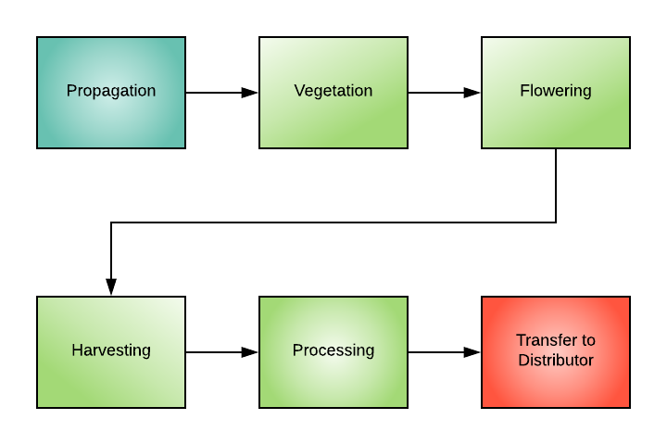

CULTIVATION OPERATIONS GENERAL PROCEDURES
The regulations contained in this chapter of the manual pertain either to all the cultivation processes shown in the above map, or to a specific process listed on the map. When you see a new map at the top of the page, you will have moved into another section of this chapter. This section you are reading now will cover regulations that are common to each process. Each process will contain references to all or some of the regulatory sections listed below. The regulatory section numbers have been preserved to make it easier to cross reference your operational policies and procedures with the state regulations during your annual review process. As regulations are updated frequently, it is recommended that all policies and procedures and the supporting regulations in this manual are reviewed and updated on an annual basis.

Definitions (All Processes)
The Cultivation Operations will use the following technical definitions when discussing regulated terms. All terms are listed in alphabetical order. Please refer to the definitions list any time clarity is needed to interpret regulated terms.

Section: 8000 Definitions
The following definitions, in addition to those stated in section 26001 of the Business and Professions Code, apply to this chapter.
- Act means the Medicinal and Adult-Use Cannabis Regulation and Safety Act, division 10, chapter 1 (commencing with section 26000) of the Business and Professions Code.
- Applicant means an owner of the applicant entity or sole proprietor applying for a state license pursuant to this division.
- Applicant entity means the entity or sole proprietor applying for a state cannabis cultivation license.
- Batch or harvest batch means a specifically identified quantity of dried flower or trim, leaves, and other cannabis plant matter that is uniform in strain or cultivar, harvested in whole, or in part, at the same time, and, if applicable, cultivated using the same pesticides and other agricultural chemicals.
- Bureau means the Bureau of Cannabis Control within the Department of Consumer Affairs, formerly named the Bureau of Marijuana Control, the Bureau of Medical Cannabis Regulation, and the Bureau of Medical Marijuana Regulation.
- Canopy means the designated area(s) at a licensed premise, except nurseries and processors, that will contain mature plants at any point in time, as follows:
- Canopy will be calculated in square feet and measured using clearly identifiable boundaries of all area(s) that will contain mature plants at any point in time, including all the space(s) within the boundaries.
- Canopy may be noncontiguous but each unique area included in the total canopy calculation will be separated by an identifiable boundary that includes, but is not limited to, interior walls, shelves, greenhouse walls, hoop house walls, garden benches, hedgerows, fencing, garden beds, or garden plots; and
- If mature plants are being cultivated using a shelving system, the surface area of each level will be included in the total canopy calculation.
- Commercial cannabis activity includes the cultivation, possession, manufacture, distribution, processing, storing, laboratory testing, packaging, labeling, transportation, delivery, or sale of cannabis and cannabis products as provided for in this chapter.
- Cultivation means any activity involving the planting, growing, harvesting, drying, curing, grading, or trimming of cannabis. Page 1 of 73
- Cultivation site means a location where commercial cannabis is planted, grown, harvested, dried, cured, graded, or trimmed, or a location where any combination of those activities occurs.
- Department means the California Department of Food and Agriculture.
- Dried flower means all dead cannabis that has been harvested, dried, cured, or otherwise processed, excluding leaves and stems.
- Flowering means that a cannabis plant has formed a mass of pistils measuring greater than one half inch wide at its widest point.
- Immature plant or immature means a cannabis plant that has a first true leaf measuring greater than one half inch long from base to tip (if started from seed) or a mass of roots measuring greater than one half inch wide at its widest point (if vegetatively propagated), but which is not flowering.
- Indoor cultivation means the cultivation of cannabis within a permanent structure using exclusively artificial light or within any type of structure using artificial light at a rate above twenty-five watts per square foot.
- Kief means the resinous trichomes of cannabis that have been separated from the cannabis plant.
- Licensee means any person holding a license pursuant to this chapter.
- Light deprivation means the use of any technique to eliminate natural light to induce flowering.
- Lot means a batch, or a specifically identified portion of a batch.
- Mature plant or mature means a cannabis plant that is flowering.
- Mixed-light cultivation means the cultivation of mature cannabis in a greenhouse, hoop-house, glasshouse, conservatory, hothouse, or other similar structure using a combination of:
- Natural light and light deprivation and one of the artificial lighting models listed below:
- Mixed-light Tier 1 without the use of artificial light or the use of artificial light at a rate above zero, but no more than six watts per square foot.
- Mixed-light Tier 2 the use of artificial light at a rate above six and below or equal to twenty-five watts per square foot; or
- Natural light and one of the artificial lighting models listed below:
- Mixed-light Tier 1 the use of artificial light at a rate above zero, but no more than six watts per square foot.
- Mixed-light Tier 2 the use of artificial light at a rate above six and below or equal to twenty-five watts per square foot.
- Net weight means the weight of harvested cannabis and cannabis products, exclusive of all materials, substances, or items not part of the commodity itself, including but not limited to containers, conveyances, bags, wrappers, packaging materials, labels, and individual piece coverings, and that meet the requirements in section 8406(b).
- Nonmanufactured cannabis product means flower, shake, leaf, pre-rolls, and kief that is obtained from accumulation in containers or sifted from loose, dry cannabis flower or leaf with a mesh screen or sieve. Page 2 of 73
- Nursery means all activities associated with producing clones, immature plants, seeds, and other agricultural products used specifically for the propagation and cultivation of cannabis.
- Outdoor cultivation means the cultivation of mature cannabis without the use of artificial lighting or light deprivation in the canopy area at any point in time. Artificial lighting is permissible only to maintain immature plants outside the canopy area.
- Pest means any of the following that is, or is liable to become, dangerous or detrimental to the agricultural or nonagricultural environment of the state:
  - Any insect, predatory animal, rodent, nematode, or weed; and
  - Any form of terrestrial, aquatic, or aerial plant or animal virus, fungus, bacteria, or other microorganism (except viruses, fungi, bacteria, or other microorganisms on or in living man or other living animals).
- Premises means the designated structure or structures and land specified in the application that is owned, leased, or otherwise held under the control of the applicant or licensee where the commercial cannabis activity will be or is conducted. The premises will be a contiguous area and will only be occupied by one licensee.
- Pre-roll means any combination of the following rolled in paper: flower, shake, leaf, or kief that is obtained from accumulation in containers or sifted from loose, dry cannabis flower or leaf with a mesh screen or sieve.
- Process, Processing, and Processes mean all activities associated with the drying, curing, grading, trimming, rolling, storing, packaging, and labeling of cannabis or nonmanufactured cannabis products.
- Track-and-trace system means the state-approved system used to track commercial cannabis activity and movement.
- Unique identifier or UID means an alphanumeric code or designation used for reference to a specific plant on a licensed premise and any cannabis or cannabis product derived or manufactured from that plant.
- Watts per square foot means the sum of the maximum wattage of all lights identified in the designated canopy area(s) in the cultivation plan divided by the sum of the dimensions in square feet of designated canopy area(s) identified in the cultivation plan.
- Wet weight means the weight of harvested, non-dried cannabis, on the licensed premises or being transported between licensees that does not meet the net weight requirements in section 8406(b).

Cultivation Plan Requirements (All Processes)
The cultivation plan prepared prior to licensing was prepared in compliance with Section 8106 as noted below. Management staff will review the following regulation annually to maintain compliance with all cultivation plan requirements

Section: 8106 Cultivation Plan Requirements: The Cultivation Operations at the facility have been designed to meet and maintain consistent compliance with Section 8106 of the CDFA Regulations.

California State Track and Trace Requirements (All Processes)
All cultivation operations will be required to follow Track and Trace system procedures at each step. The complete list of regulated procedures follows. A printable checklist for following these procedures can be found at the end of this section. Place this checklist at each workstation and with each employee that interacts with the state track and trace system

Section: 8403 Track-and-Trace System Unique Identifiers (UID)
  - All Track and Trace account requirements will be followed including but not limited to:
- A designated account manager will be credentialed by the department
- Only UIDs distributed by the department or department’s designee will be used onsite
- A sufficient supply of UIDs will always be kept in the inventory to support onsite tagging needs
- The State Track and Trace system will be used to document all required activities starting with seed, cannabis which has been propagated onsite or purchased from a licensed nursery, or seedling purchased from a licensed nursery.
  - UIDs will accompany the cannabis products through all phases of the growing cycle, as follows:
- Each lot of immature plants will have a UID assigned each established lot, respectively. The lot UID will be placed in a position so it is visible and within clear view of an individual standing next to the immature lot to which the UID was assigned, and all UIDs will be kept free from dirt and debris. Immature plants will be uniform in strain or cultivar and will not have more than one hundred (100) immature plants at any one time. All immature plants in a lot will be labeled with the corresponding UID number assigned to the lot and will be contiguous to one another to facilitate identification by the department.
- All Immature plants transferred from a licensed nursery, via a distributor, to a licensed cultivator will meet CDFA requirements. Each immature plant intended for retail sale will have a UID affixed or be labeled with the corresponding UID number of the lot and be recorded in the track-and-trace system prior to transfer from the licensed nursery.
- A UID will be applied to all individual plants at the time any plant is moved to the designated canopy area or when an individual plant begins flowering. Individual immature plants may be tagged prior to movement to the designated canopy area or prior to flowering.
- UIDs are required for each mature plant. UIDs will be attached to the main stem, at the base of each plant. The UID will be attached to the plant using a tamper evident strap or zip tie and placed in a position so it is visible and within clear view of an individual standing next to the mature plant to which the UID was assigned and UIDs will be kept free from dirt and debris. Licensees are prohibited from removing the UID from the mature plant to which it was attached and assigned until the plant is harvested, destroyed, or disposed.
  - Each harvest batch will be assigned a unique harvest batch name which will be associated with all UIDs for each individual plant, or portion thereof, contained in the harvest batch.
  - UIDs are required for all cannabis and nonmanufactured cannabis products and will be associated with the corresponding harvest batch name from which the cannabis and nonmanufactured cannabis products were derived.
  - Upon destruction or disposal of any cannabis or nonmanufactured cannabis products, the applicable UIDs will be retired in the track-and-trace system by The facility within three (3) calendar days of the destruction or disposal and be performed in accordance with The facility’s approved cannabis waste management plan.

SECTION CHECKLISTS
The following checklists may be printed and placed at workstations and/or with employees that must carry out the associated tasks.
Indoor Cultivation Requirements Checklist
q | Ensure that cannabis plants maintained outside of the designated canopy area(s) are prohibited from flowering
q | Ensure that if a plant does flower it will be moved to the designated canopy and recorded without delay in the state track and trace system
q | Ensure that all portions of a plant used for seed production will be tagged with a UID pursuant to section 8403
q | Ensure that harvested cannabis is processed only in designated areas

Section 8403 Checklist for METRC Compliance
q | Ensure that a designated account manager has been credentialed by the BCC
q | Ensure only UIDs distributed by the department are used onsite
q | Ensure a sufficient supply of UIDs are kept in inventory
q | Ensure all movement of inventory is entered in the track and trace system (including new propagation or purchase)

UID Track and Trace Checklist
q | Ensure all lots of immature plants are assigned a UID
q | Ensure UIDs are visible and within clear view of bystanders and free from dirt or debris
q | Ensure that lots are no more than 100 immature plants
q | Ensure that all plants in the lot are labeled with the corresponding UID lot number
q | Ensure that all plants in the lot are contiguous
q | Ensure that each immature plant intended for retail sale will have a UID affixed or be labeled with the corresponding UID number of the lot and be recorded in the track and trace system prior to transfer
q | Ensure that a UID is applied to all individual plants at the time any plant is moved or begins flowering (individual immature plants can be tagged prior to movement to designated canopy area or prior to flowering)
q | Ensure that UIDs are attached to each mature plat at the base of the main stem of each plant
q | Ensure that UIDs attached to mature plants are attached with a tamper evident strap or zip tie
q | Ensure that UIDs attached to mature plants kept free of dirt & debris
q | Ensure that UIDs attached to mature plants are in clear view of an individual standing next to them
q | Ensure that UIDs follow the mature plant and remain attached until the plant is harvested, destroyed or disposed
q | Ensure that a harvest batch name has been assigned to each harvest batch with a unique name that will be associated with all UIDs for each individual plant or portion of the plant from the batch
q | Ensure that the Harvest name remains associated with all cannabis from the batch through all modifications and derivations of the cannabis product after harvest
q | Ensure that UIDs from destructed or disposed cannabis or nonmanufactured cannabis products will be retired in the Track and Trace system within three days of destruction/disposal

PROPAGATION PROCESS MAP

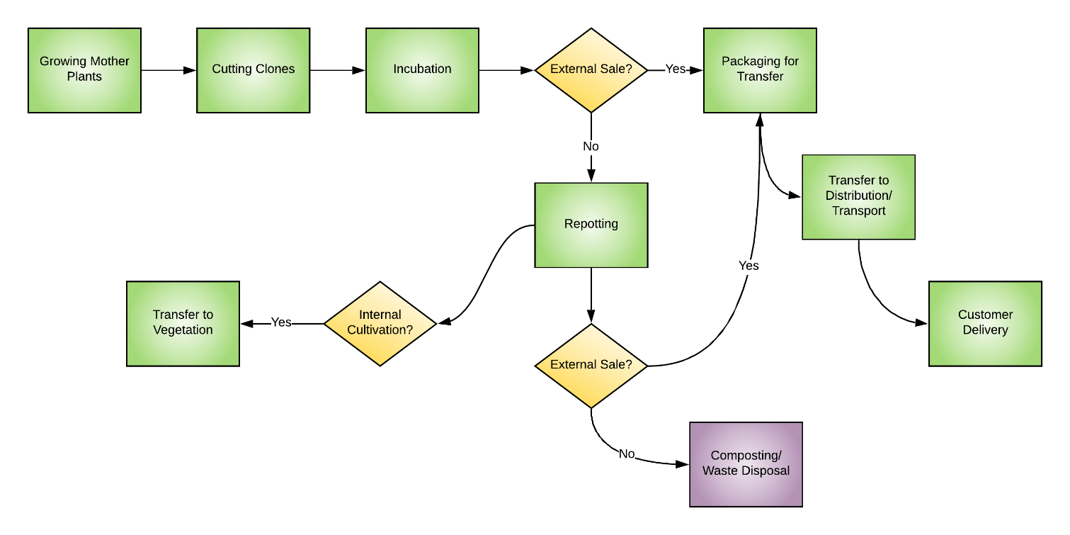

PROPAGATION POLICY
It is the Policy of the company that Propagation steps will be overseen by the Master Grower at the facility who may modify the above process to accommodate specific goals that have been approved by the license holder. Modifications to this process will be made in accordance to the company policy for creating changes to the SOP manual which includes approval by the license holder. Any modifications will always also be checked against regulations and ordinances by the compliance manager to ensure consistent compliance.
The facility will carry out all propagation activities in accordance with the above-referenced flowchart. A printable checklist with each individual step can be found at the end of this section.

PROPAGATION PROCEDURE
In addition to the above listed steps, all propagation activities will comply with the general sections found at the beginning of the CULTIVATION OPERATIONS section of this manual. A separate checklist of propagation activities will be found at the end of this section.

All the following general sections apply to activities undertaken during the propagation process:

8000 Definitions

8106 Cultivation Plan Requirements

8403 Track-and-Trace System Unique Identifiers (UID)

SECTION CHECKLISTS
The following checklists may be printed and placed at workstations and/or with employees that must carry out the associated tasks.
Please note that this manual focuses on regulations associated with each process at your facility. Specific regulations that must be followed will be listed in the procedures section and will also be accompanied by a checklist. If only a basic checklist is shown, that means that only the general procedures and procedures created in-house by the facility and master grower apply.
If your company would like assistance building out policies and procedures for in-house standards, please reach out to Begreenlegal Cannabis Consultants for additional assistance in developing your internal standard operating procedures and training.

Propagation Steps Checklist

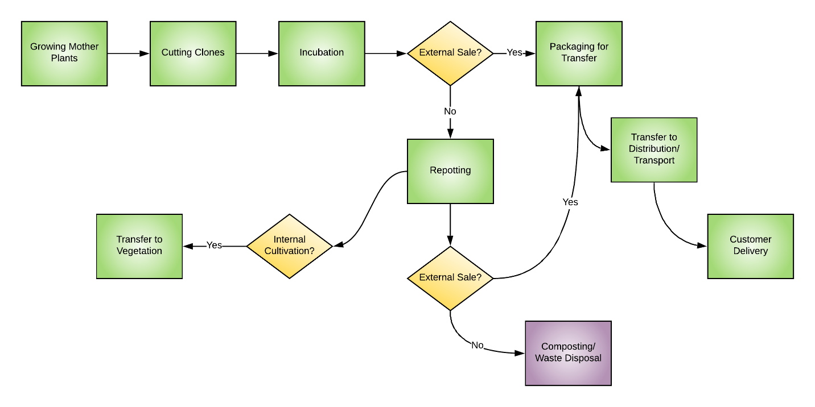

q | Grow Mother Plants
q | Cut Clones
q | Incubate Clones
q | Repot Clones for additional vegetation; or
q | Package clones for transfer
q | Transfer clones to Distribution/Transport
q | Compost or Disposal of clones as necessary

UID Track and Trace Checklist
q | Ensure all lots of immature plants are assigned a UID
q | Ensure UIDs are visible and within clear view of bystanders and free from dirt or debris
q | Ensure that lots are no more than 100 immature plants
q | Ensure that all plants in the lot are labeled with the corresponding UID lot number
q | Ensure that all plants in the lot are contiguous
q | Ensure that each immature plant intended for retail sale will have a UID affixed or be labeled with the corresponding UID number of the lot and be recorded in the track and trace system prior to transfer
q | Ensure that a UID is applied to all individual plants at the time any plant is moved or begins flowering (individual immature plants can be tagged prior to movement to designated canopy area or prior to flowering)
q | Ensure that UIDs are attached to each mature plat at the base of the main stem of each plant
q | Ensure that UIDs attached to mature plants are attached with a tamper evident strap or zip tie
q | Ensure that UIDs attached to mature plants kept free of dirt & debris
q | Ensure that UIDs attached to mature plants are in clear view of an individual standing next to them
q | Ensure that UIDs follow the mature plant and remain attached until the plant is harvested, destroyed or disposed
q | Ensure that a harvest batch name has been assigned to each harvest batch with a unique name that will be associated with all UIDs for each individual plant or portion of the plant from the batch
q | Ensure that the Harvest name remains associated with all cannabis from the batch through all modifications and derivations of the cannabis product after harvest
q | Ensure that UIDs from destructed or disposed cannabis or nonmanufactured cannabis products will be retired in the Track and Trace system within three days of destruction/disposal

VEGETATION PROCESS MAP

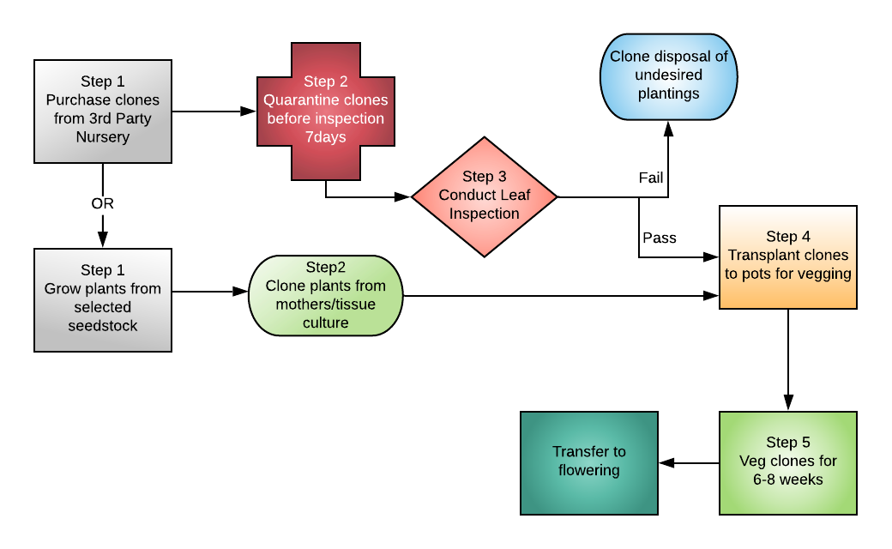

VEGETATION POLICY
It is the Policy of the company that Vegetation steps will be overseen by the Master Grower at the facility who may modify the above process to accommodate specific goals that have been approved by the license holder. Modifications to this process will be made in accordance to the company policy for creating changes to the SOP manual which includes approval by the license holder. Any modifications will always also be checked against regulations and ordinances by the compliance manager to ensure consistent compliance.
The facility will carry out all vegetation activities in accordance with the above-referenced flowchart. A printable checklist with each individual step can be found at the end of this section.

VEGETATION PROCEDURE
In addition to the above listed steps, all vegetation-related activities will comply with the general sections found at the beginning of the CULTIVATION OPERATIONS section of this manual. A separate checklist of these activities will be found at the end of this section.

All the following general sections apply to activities undertaken during the vegetation process:

8000 Definitions

8106 Cultivation Plan Requirements

8403 Track-and-Trace System Unique Identifiers (UID)

SECTION CHECKLISTS
The following checklists may be printed and placed at workstations and/or with employees that must carry out the associated tasks.
Please note that this manual focuses on regulations associated with each process at your facility. Specific regulations that must be followed will be listed in the procedures section and will also be accompanied by a checklist. If only a basic checklist is shown, that means that only the general procedures and procedures created in-house by the facility and master grower apply.
If your company would like assistance building out policies and procedures for in-house standards, please reach out to Begreenlegal Cannabis Consultants for additional assistance in developing your internal standard operating procedures and training.

Vegetation Steps Checklist
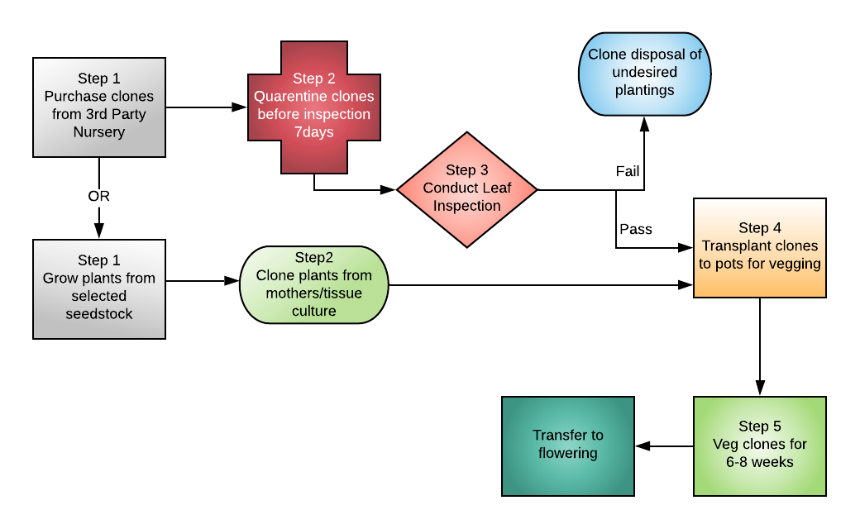

q | Purchase or cut clones
q | Quarantine purchased clones before inspection (7 days)
q | Conduct a leaf inspection
q | Dispose of undesired plantings in accordance with waste management procedures
q | Transplant clones to pots for vegging
q | Transfer clones to Distribution/Transport
q | Compost or Disposal of clones as necessary

UID Track and Trace Checklist
q | Ensure all lots of immature plants are assigned a UID
q | Ensure UIDs are visible and within clear view of bystanders and free from dirt or debris
q | Ensure that lots are no more than 100 immature plants
q | Ensure that all plants in the lot are labeled with the corresponding UID lot number
q | Ensure that all plants in the lot are contiguous
q | Ensure that each immature plant intended for retail sale will have a UID affixed or be labeled with the corresponding UID number of the lot and be recorded in the track and trace system prior to transfer
q | Ensure that a UID is applied to all individual plants at the time any plant is moved or begins flowering (individual immature plants can be tagged prior to movement to designated canopy area or prior to flowering)
q | Ensure that UIDs are attached to each mature plat at the base of the main stem of each plant
q | Ensure that UIDs attached to mature plants are attached with a tamper evident strap or zip tie
q | Ensure that UIDs attached to mature plants kept free of dirt & debris
q | Ensure that UIDs attached to mature plants are in clear view of an individual standing next to them
q | Ensure that UIDs follow the mature plant and remain attached until the plant is harvested, destroyed or disposed
q | Ensure that a harvest batch name has been assigned to each harvest batch with a unique name that will be associated with all UIDs for each individual plant or portion of the plant from the batch
q | Ensure that the Harvest name remains associated with all cannabis from the batch through all modifications and derivations of the cannabis product after harvest
q | Ensure that UIDs from destructed or disposed cannabis or nonmanufactured cannabis products will be retired in the Track and Trace system within three days of destruction/disposal

FLOWERING PROCESS MAP

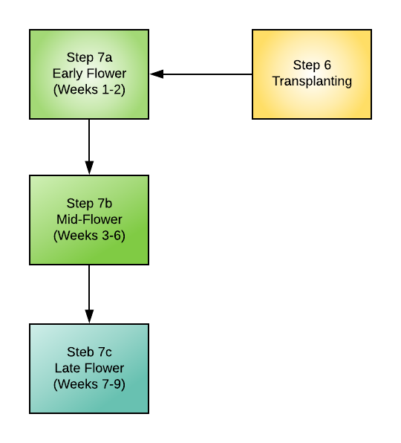

FLOWERING POLICY
It is the Policy of the company that Flowering steps will be overseen by the Master Grower at the facility who may modify the above process to accommodate specific goals that have been approved by the license holder. Modifications to this process will be made in accordance to the company policy for creating changes to the SOP manual which includes approval by the license holder. Any modifications will always also be checked against regulations and ordinances by the compliance manager to ensure consistent compliance.
The facility will carry out all flowering activities in accordance with the above-referenced flowchart. A printable checklist with each individual step can be found at the end of this section.

FLOWERING PROCEDURE
Flowering activities at the facility will be carefully planned and indicated by the facility Master Grower who will oversee the schedules for watering, nutrients, pesticide application. All schedules will be posted in conspicuous areas of the cultivation facility to ensure that staff is able to continually reference and follow the designated schedule.
A general flowering structure is listed above. In addition to the above listed steps, all vegetation-related activities will comply with the general sections found at the beginning of the CULTIVATION OPERATIONS section of this manual. A separate checklist of these activities will be found at the end of this section.

All the following general sections apply to activities undertaken during the flowers process:

8000 Definitions

8106 Cultivation Plan Requirements

8403 Track-and-Trace System Unique Identifiers (UID)

Flowering operations require oversight related to some additional regulations of the CDFA as follows:

Section: 8300 Cultivation Requirements for Specialty Cottage, Specialty, Small, and Medium Licenses
- Cannabis plants maintained outside of the designated canopy area(s) for specialty cottage, specialty, small, and medium licenses are prohibited from flowering. Should plants outside of the canopy area(s) begin to flower, a UID will be applied, the plant(s) will be moved to the designated canopy area without delay and reported in the track-and-trace system.
- All plants or portions of a plant used for seed production will be tagged with a UID pursuant to section 8403.
- Licensees propagating immature plants for distribution or seed for distribution to another licensee will obtain a nursery license.
- Licensees will process their harvested cannabis only in area(s) designated for processing in their cultivation plan provided they are compliant with packaging and labeling requirements pursuant to section 8212 of this chapter, or transfer their harvested cannabis to a licensed processor, manufacturer, or distributor via a licensed distributor.

SECTION CHECKLISTS
In addition to nutrient, pest and watering schedules that may be created and dispersed to employees of the facility, the following checklists may be printed and placed at workstations and/or with employees that must carry out the associated tasks.
Please note that this manual focuses on regulations associated with each process at your facility. Specific regulations that must be followed will be listed in the procedures section and will also be accompanied by a checklist. If only a basic checklist is shown, that means that only the general procedures and procedures created in-house by the facility and master grower apply.
If your company would like assistance building out policies and procedures for in-house standards, please reach out to Begreenlegal Cannabis Consultants for additional assistance in developing your internal standard operating procedures and training.

Flowering Steps Checklist
q | Transplant to vegetation
q | Early flower plants (weeks 1-2)
q | Mid flower plants (weeks 3-6)
q | Late flower plants (weeks 7-9)

Indoor Cultivation Requirements Checklist
q | Ensure that cannabis plants maintained outside of the designated canopy area(s) are prohibited from flowering
q | Ensure that if a plant does flower it will be moved to the designated canopy and recorded without delay in the state track and trace system
q | Ensure that all portions of a plant used for seed production will be tagged with a UID pursuant to section 8403
q | Ensure that harvested cannabis is processed only in designated areas

UID Track and Trace Checklist
q | Ensure all lots of immature plants are assigned a UID
q | Ensure UIDs are visible and within clear view of bystanders and free from dirt or debris
q | Ensure that lots are no more than 100 immature plants
q | Ensure that all plants in the lot are labeled with the corresponding UID lot number
q | Ensure that all plants in the lot are contiguous
q | Ensure that each immature plant intended for retail sale will have a UID affixed or be labeled with the corresponding UID number of the lot and be recorded in the track and trace system prior to transfer
q | Ensure that a UID is applied to all individual plants at the time any plant is moved or begins flowering (individual immature plants can be tagged prior to movement to designated canopy area or prior to flowering)
q | Ensure that UIDs are attached to each mature plat at the base of the main stem of each plant
q | Ensure that UIDs attached to mature plants are attached with a tamper evident strap or zip tie
q | Ensure that UIDs attached to mature plants kept free of dirt & debris
q | Ensure that UIDs attached to mature plants are in clear view of an individual standing next to them
q | Ensure that UIDs follow the mature plant and remain attached until the plant is harvested, destroyed or disposed
q | Ensure that a harvest batch name has been assigned to each harvest batch with a unique name that will be associated with all UIDs for each individual plant or portion of the plant from the batch
q | Ensure that the Harvest name remains associated with all cannabis from the batch through all modifications and derivations of the cannabis product after harvest
q | Ensure that UIDs from destructed or disposed cannabis or nonmanufactured cannabis products will be retired in the Track and Trace system within three days of destruction/disposal

HARVESTING PROCESS MAP

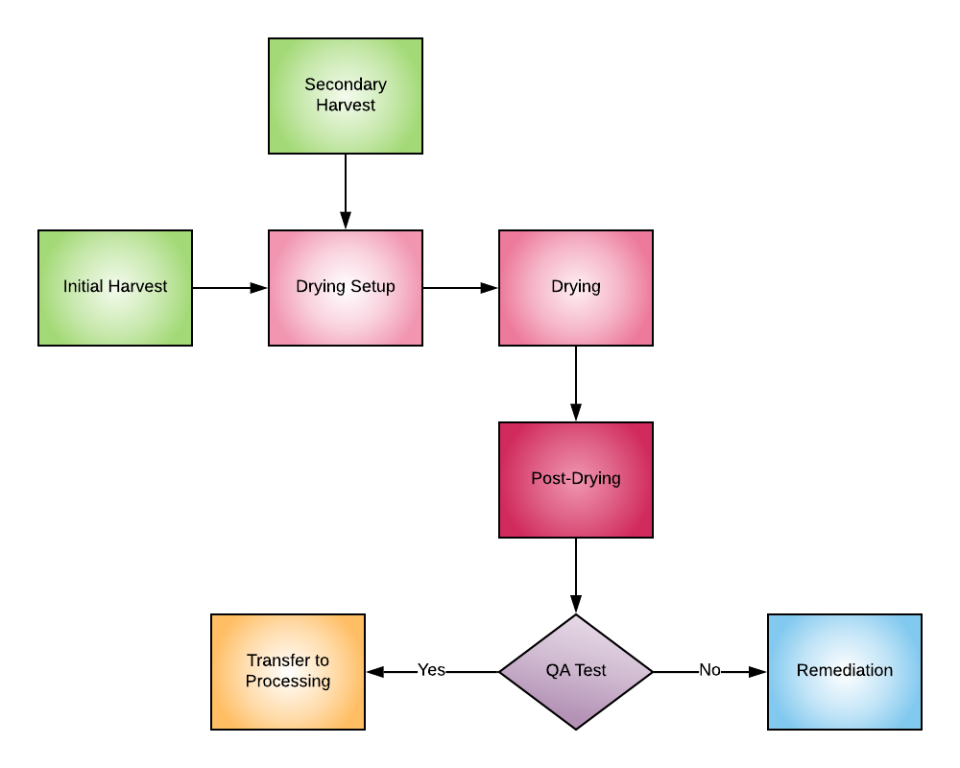

HARVESTING POLICY
It is the Policy of the company that harvesting tasks in all phases will be overseen by the Master Grower at the facility, who will be responsible for setting the procedures for harvesting at the facility in accordance with the mapped process, and who may modify the above process to accommodate specific goals that have been approved by the license holder. Modifications to this process will be made in accordance to the company policy for creating changes to the SOP manual which includes approval by the license holder. Any modifications will always also be checked against regulations and ordinances by the compliance manager to ensure consistent compliance.
The facility will carry out all harvesting activities in accordance with the above-referenced flowchart. A printable checklist with each individual step can be found at the end of this section.

HARVESTING PROCEDURE
Harvesting activities at the facility will be carefully planned and indicated by the facility Master Grower who will oversee the advancement of flowering and develop set schedules for harvesting at the appropriate stages of growth. All schedules will be posted in the harvesting areas of the cultivation facility to ensure that staff is able to continually reference and follow the designated schedule.
In addition to the above listed steps, all harvest-related activities will comply with the general sections found at the beginning of the CULTIVATION OPERATIONS section of this manual. A separate checklist of harvest activities that is guided by the process map will be found at the end of this section.

All the following general sections apply to activities undertaken during the harvesting process:

8000 Definitions

8106 Cultivation Plan Requirements

8403 Track-and-Trace System Unique Identifiers (UID)

SECTION CHECKLIST
In addition to flowering and harvesting schedules that may be created and dispersed to employees of the facility, the following checklists may be printed and placed at workstations and/or with employees that must carry out the associated tasks.
Please note that this manual focuses on regulations associated with each process at your facility. Specific regulations that must be followed will be listed in the procedures section and will also be accompanied by a checklist. If only a basic checklist is shown, that means that only the general procedures and procedures created in-house by the facility and master grower apply.
If your company would like assistance building out policies and procedures for in-house standards, please reach out to Begreenlegal Cannabis Consultants for additional assistance in developing your internal standard operating procedures and training.

Initial Harvest Checklist

q | Set areas up for drying
q | Move plants to drying area
q | Post-drying check
q | QA Test
q | If passes QA – transfer to processing
q | If does not pass QA – transfer to remediation

Secondary Harvest Checklist

q | Set areas up for drying
q | Move plants to drying area
q | Post-drying check
q | QA Test
q | If passes QA – transfer to processing
q | If does not pass QA – transfer to remediation

UID Track and Trace Checklist
q | Ensure all lots of immature plants are assigned a UID
q | Ensure UIDs are visible and within clear view of bystanders and free from dirt or debris
q | Ensure that lots are no more than 100 immature plants
q | Ensure that all plants in the lot are labeled with the corresponding UID lot number
q | Ensure that all plants in the lot are contiguous
q | Ensure that each immature plant intended for retail sale will have a UID affixed or be labeled with the corresponding UID number of the lot and be recorded in the track and trace system prior to transfer
q | Ensure that a UID is applied to all individual plants at the time any plant is moved or begins flowering (individual immature plants can be tagged prior to movement to designated canopy area or prior to flowering)
q | Ensure that UIDs are attached to each mature plat at the base of the main stem of each plant
q | Ensure that UIDs attached to mature plants are attached with a tamper evident strap or zip tie
q | Ensure that UIDs attached to mature plants kept free of dirt & debris
q | Ensure that UIDs attached to mature plants are in clear view of an individual standing next to them
q | Ensure that UIDs follow the mature plant and remain attached until the plant is harvested, destroyed or disposed
q | Ensure that a harvest batch name has been assigned to each harvest batch with a unique name that will be associated with all UIDs for each individual plant or portion of the plant from the batch
q | Ensure that the Harvest name remains associated with all cannabis from the batch through all modifications and derivations of the cannabis product after harvest
q | Ensure that UIDs from destructed or disposed cannabis or nonmanufactured cannabis products will be retired in the Track and Trace system within three days of destruction/disposal

PROCESSING PROCESS MAP

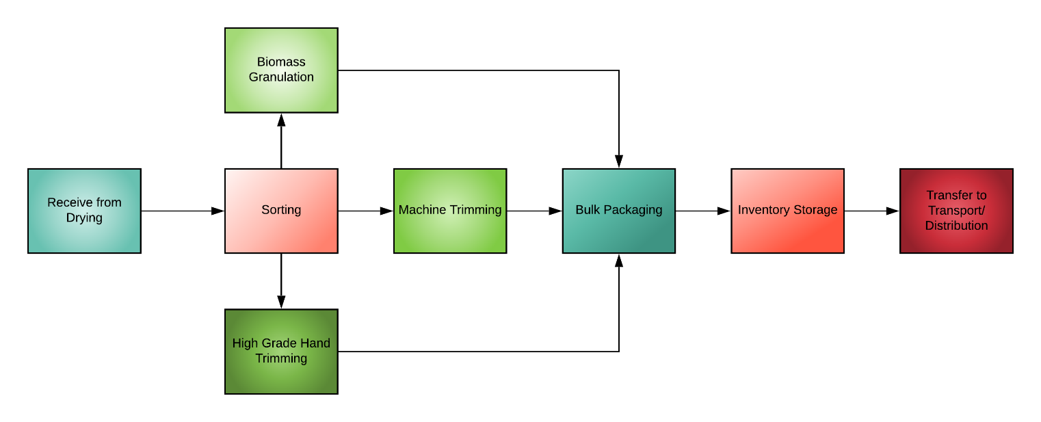

PROCESSING POLICY
It is the Policy of the company that all tasks related to processing of cannabis or cannabis products at the facility be overseen by the Master Grower at the facility. The Master Grower will be responsible for setting the procedures for harvesting at the facility in accordance with the mapped process and may modify the above process to accommodate specific goals that have been approved by the license holder. Modifications to this process will be made in accordance with the company policy for creating changes to the SOP manual which includes approval by the license holder. Any modifications will always also be checked against regulations and ordinances by the compliance manager to ensure consistent compliance.
The facility will carry out all processing activities in accordance with the above-referenced flowchart. A printable checklist with each individual step can be found at the end of this section.

PROCESSING PROCEDURE
Processing activities at the facility will be carefully planned and indicated by the facility Master Grower who will oversee the drying and trimming of harvested cannabis and develop set standards for ensuring quality control and consistent production. In addition, the Cultivation manager or master grower if it is the same person filling that role, will be responsible for creating procedures for consistent packaging and labeling at the facility. Additional checklists have been provided in this section to cover all of the regulated requirements for packaging and labeling. All checklists will be posted in the processing areas of the cultivation facility where packaging and labeling activities will occur, to ensure that staff is able to produce consistent and compliant packaged and labeled products.
In addition to the above listed steps, all processing-related activities will comply with the general sections found at the beginning of the CULTIVATION OPERATIONS section of this manual. A separate checklist of processing activities that is guided by the process map will be found at the end of this section.

All the following general sections apply to activities undertaken during the processing process:

8000 Definitions

8106 Cultivation Plan Requirements

8403 Track-and-Trace System Unique Identifiers (UID)

The facility will be responsible for following all regulations for compliant packaging and labeling. Please refer to the printable checklists found at the end of this section for an easy visual list of important steps that must always be followed regardless of additional or adjunct internal processes.

Section 8212: Packaging and Labeling of Cannabis and Nonmanufactured Cannabis Products
  - All cannabis and nonmanufactured cannabis products packaged and/or labeled by a licensed cultivator will meet all applicable requirements of sections 26123 and 26121 of the Business & Professions Code as well as any other requirements for cannabis and nonmanufactured cannabis products specified by the California Department of Public Health including:
- All packages for retail sale, excluding those containing immature plants and seeds, will be child resistant.
  - A label may specify the county of origin only if one hundred (100) percent of the cannabis or nonmanufactured cannabis product contained in the package was produced within the designated county, as defined by finite political boundaries.

At least one certified weighmaster must be on staff to provide certified weighs and quantities of packaged cannabis product intended for further processing by manufacturing or for retail sales. The following sections apply to requirements of the weighmaster. Additional checklists can be found at the end of this section for an easy visual list of important steps that must always be followed regardless of additional or adjunct internal processes.

Section: 8213 Requirements for Weighing Devices and Weighmasters
- Weighing devices used by a licensee will be approved, registered, tested, and sealed in accordance with the Business and professions Code (BPC) (Chapter 5, 12500) and registered with the county sealer consistent with BPC Chapter 2 (commencing with section 12240 of division 5) and its implementing regulations. Approved, registered, tested, and sealed devices will be used whenever any one or more of the following apply:
- Cannabis and nonmanufactured cannabis products are bought or sold by weight or count.
- Cannabis and nonmanufactured cannabis products are packaged for sale by weight or count.
- Cannabis and nonmanufactured cannabis products are weighed or counted for entry into the track-and-trace system; or
- The weighing device is used for commercial purposes as defined in section 12500 of the Business and Professions Code.
- In any county in which a sealer is unable or not required to approve, register, test, and seal weighing devices used by a licensee, the department may perform the duties of the county sealer in the same manner, to the same extent, and with the same authority as if it had been the duly appointed sealer in such county. In those instances, the department will charge a licensee for its services using the schedule of fees established in Business and Professions Code section 12240.
- For the purposes of this chapter a licensee must use wet weight or net weight. Wet weight and net weight will be measured, recorded, and reported in U.S. customary units (e.g., ounce or pound); or International System of Units (e.g., kilograms, grams, or milligrams).
- For the purposes of this chapter, count means the numerical count of the individual cannabis plants, seeds, or nonmanufactured cannabis product units.
- Any licensee weighing or measuring cannabis or nonmanufactured cannabis product in accordance with subsection (a) will be licensed as a weighmaster.
- A licensed weighmaster will issue a weighmaster certificate whenever payment for the commodity or any charge for service or processing of the commodity is dependent upon the quantity determined by the weighmaster in accordance with section 12711 of the Business and Professions Code and will be consistent with the requirements in chapter 7 (commencing with section 12700) of division 5 of the Business and Professions Code.

Processing has specific requirements for indoor cultivation as noted in subsection (h) below.

Section: 8300 Cultivation Requirements for Specialty Cottage, Specialty, Small, and Medium Licenses
- Cannabis plants maintained outside of the designated canopy area(s) for specialty cottage, specialty, small, and medium licenses are prohibited from flowering. Should plants outside of the canopy area(s) begin to flower, a UID will be applied, the plant(s) will be moved to the designated canopy area without delay and reported in the track-and-trace system.
- All plants or portions of a plant used for seed production will be tagged with a UID pursuant to section 8403 of this chapter.
- Licensees propagating immature plants for distribution or seed for distribution to another licensee will obtain a nursery license.
- Licensees will process their harvested cannabis only in area(s) designated for processing in their cultivation plan provided they are compliant with packaging and labeling requirements pursuant to section 8212 of this chapter, or transfer their harvested cannabis to a licensed processor, manufacturer, or distributor via a licensed distributor.

Following are a few important requirements for seed production as well as research and development. The facility has indicated a small seed production room and R&D area which will be required to adhere to the following.

Section: 8301 Seed Production Requirements for Nursery Licensees
- Nursery licensees producing seed for distribution will tag all mature plants with a UID pursuant to section 8403(b)(4).
- All products, except seed, derived from these plants are prohibited from entering the commercial distribution chain.

Section: 8302 Research and Development Requirements for Nursery Licensees
- Nursery licensees may maintain a research and development area, as identified in their cultivation plan, for the cultivation of mature plants.
- All mature plants will be tagged with a UID pursuant to section 8403.
- All products derived from these plants are prohibited from entering the commercial distribution chain.
Separate processing licensees are subject to the following:

Section: 8303 Cultivation Requirements for Processor Licensees (for reference only)
Processor licensees will comply with all the following requirements:
- All aggregation of product will adhere to track-and-trace requirements pursuant to sections 8405 and 8406;
- Licensees may produce nonmanufactured cannabis products without a manufacturing license, provided packaging and labeling requirements are met pursuant to section 8212 of this chapter; and
- Cultivation of cannabis plants is prohibited at a licensed processor premises.

SECTION CHECKLISTS
In addition to specific standards for processing cannabis that may be created and dispersed to employees of the facility, the following checklists may be printed and placed at workstations and/or with employees that must carry out the associated tasks.
Please note that this manual focuses on regulations associated with each process at your facility. Specific regulations that must be followed will be listed in the procedures section and will also be accompanied by a checklist. If only a basic checklist is shown, that means that only the general procedures and procedures created in-house by the facility and master grower apply.
If your company would like assistance building out policies and procedures for in-house standards, please reach out to Begreenlegal Cannabis Consultants for additional assistance in developing your internal standard operating procedures and training.

Processing Steps Checklist

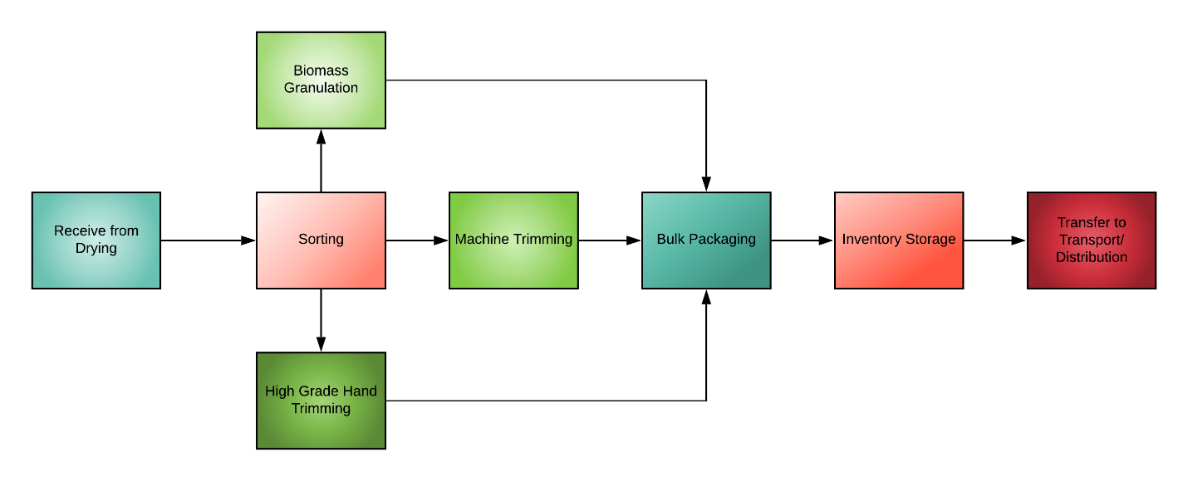

q | Receive items from drying
q | Sort items into biomass granulation and high-grade hand trimming
q | Bulk package all processed items
q | Move packaged items to inventory
q | Transfer inventory to Transport/Distribution

Packaging and Labeling Checklist (Includes BPC Compliance)
q | Ensure that only child resistant packaging is used
q | Ensure that packages and labels are not attractive to children
q | Ensure that packages are not made of transparent material
q | Ensure that names do not resemble the name of a candy, snack food, baked good or beverage commercially sold without cannabis
q | Ensure that design elements do not resemble the name of a candy, snack food, baked good or beverage commercially sold without cannabis
q | Ensure that no statements, artwork, designs, slogans, cartoons or logos contained on the labeling would be appealing to a person under the age of 21
q | Ensure the proper branding and labeling accuracy of all product packaging
q | Ensure that labels specify the county of origin only if 100% of the cannabis in the package was produced within the designated county
q | Ensure that all product labels and inserts include the following  information, prominently displayed in a clear and legible fashion in at least 8pt font or larger:
For marijuana: GOVERNMENT WARNING: THIS PACKAGE CONTAINS MARIJUANA, A SCHEDULE I CONTROLLED SUBSTANCE. KEEP OUT OF REACH OF CHILDREN AND ANIMALS. MARIJUANA MAY ONLY BE POSSESSED OR CONSUMED BY PERSONS 21 YEARS OF AGE OR OLDER UNLESS THE PERSON IS A QUALIFIED PATIENT. MARIJUANA USE WHILE PREGNANT OR BREASTFEEDING
Packaging and Labeling Checklist pg.2 (Includes BPC Compliance)

MAY BE HARMFUL. CONSUMPTION OF MARIJUANA IMPAIRS YOUR ABILITY TO DRIVE AND OPERATE MACHINERY. PLEASE USE EXTREME CAUTION.
 | For marijuana products: GOVERNMENT WARNING: THIS PRODUCT CONTAINS MARIJUANA, A SCHEDULE I CONTROLLED SUBSTANCE. KEEP OUT OF REACH OF CHILDREN AND ANIMALS. MARIJUANA PRODUCTS MAY ONLY BE POSSESSED OR CONSUMED BY PERSONS 21 YEARS OF AGE OR OLDER UNLESS THE PERSON IS A QUALIFIED PATIENT. THE INTOXICATING EFFECTS OF MARIJUANA PRODUCTS MAY BE DELAYED UP TO TWO HOURS. MARIJUANA USE WHILE PREGNANT OR BREASTFEEDING MAY BE HARMFUL. CONSUMPTION OF MARIJUANA PRODUCTS IMPAIRS YOUR ABILITY TO DRIVE AND OPERATE MACHINERY. PLEASE USE EXTREME CAUTION.
q | Ensure that all packages containing only dried flower include the net weight of marijuana in the package
q | Ensure the source and date of cultivation, type of marijuana or marijuana product and the date of manufacturing and packaging is listed on each label
q | Ensure that if an appellation of origin exists, it is included
q | Ensure that all of the pharmacologically active ingredients are listed (including THC, CBD and other cannabinoids)
q | Ensure that all ingredients and nutritional information are shown  Packaging and Labeling Checklist pg.3 (Includes BPC Compliance)
q | Ensure that a list of any solvents, nonorganic pesticides, herbicides, and fertilizers that were used in the cultivation, production, and manufacture of such marijuana or marijuana product
q | Ensure that if nuts or other known allergens are used, a warning is listed on the label
q | Ensure that only generic food names may be used to describe ingredients in edible marijuana products

Indoor Cultivation Requirements Checklist
q | Ensure that cannabis plants maintained outside of the designated canopy area(s) are prohibited from flowering
q | Ensure that if a plant does flower it will be moved to the designated canopy and recorded without delay in the state track and trace system
q | Ensure that all portions of a plant used for seed production will be tagged with a UID pursuant to section 8403
q | Ensure that harvested cannabis is processed only in designated areas

Seed Production & Research/Development Requirements Checklist
q | Ensure that all mature plants used for seed production are tagged with a UID in accordance with the track and trace checklist
q | Ensure that all mature plants used for R&D are tagged in accordance with the track and trace checklist
q | Ensure that all products, except seed, that are derived from plants used for seed production are prohibited from entering the commercial distribution chain
q | Ensure that all products, except seed, that are derived from plants used for Research & Development are prohibited from entering the commercial distribution chain
q | Ensure that all portions of a plant used for seed production will be tagged with a UID pursuant to section 8403
q | Ensure that harvested cannabis is processed only in designated areas

UID Track and Trace Checklist
q | Ensure all lots of immature plants are assigned a UID
q | Ensure UIDs are visible and within clear view of bystanders and free from dirt or debris
q | Ensure that lots are no more than 100 immature plants
q | Ensure that all plants in the lot are labeled with the corresponding UID lot number
q | Ensure that all plants in the lot are contiguous
q | Ensure that each immature plant intended for retail sale will have a UID affixed or be labeled with the corresponding UID number of the lot and be recorded in the track and trace system prior to transfer
q | Ensure that a UID is applied to all individual plants at the time any plant is moved or begins flowering (individual immature plants can be tagged prior to movement to designated canopy area or prior to flowering)
q | Ensure that UIDs are attached to each mature plat at the base of the main stem of each plant
q | Ensure that UIDs attached to mature plants are attached with a tamper evident strap or zip tie
q | Ensure that UIDs attached to mature plants kept free of dirt & debris
q | Ensure that UIDs attached to mature plants are in clear view of an individual standing next to them
q | Ensure that UIDs follow the mature plant and remain attached until the plant is harvested, destroyed or disposed
q | Ensure that a harvest batch name has been assigned to each harvest batch with a unique name that will be associated with all UIDs for each individual plant or portion of the plant from the batch
q | Ensure that the Harvest name remains associated with all cannabis from the batch through all modifications and derivations of the cannabis product after harvest
q | Ensure that UIDs from destructed or disposed cannabis or nonmanufactured cannabis products will be retired in the Track and Trace system within three days of destruction/disposal

TRANSFER TO DISTRIBUTOR PROCESS MAP

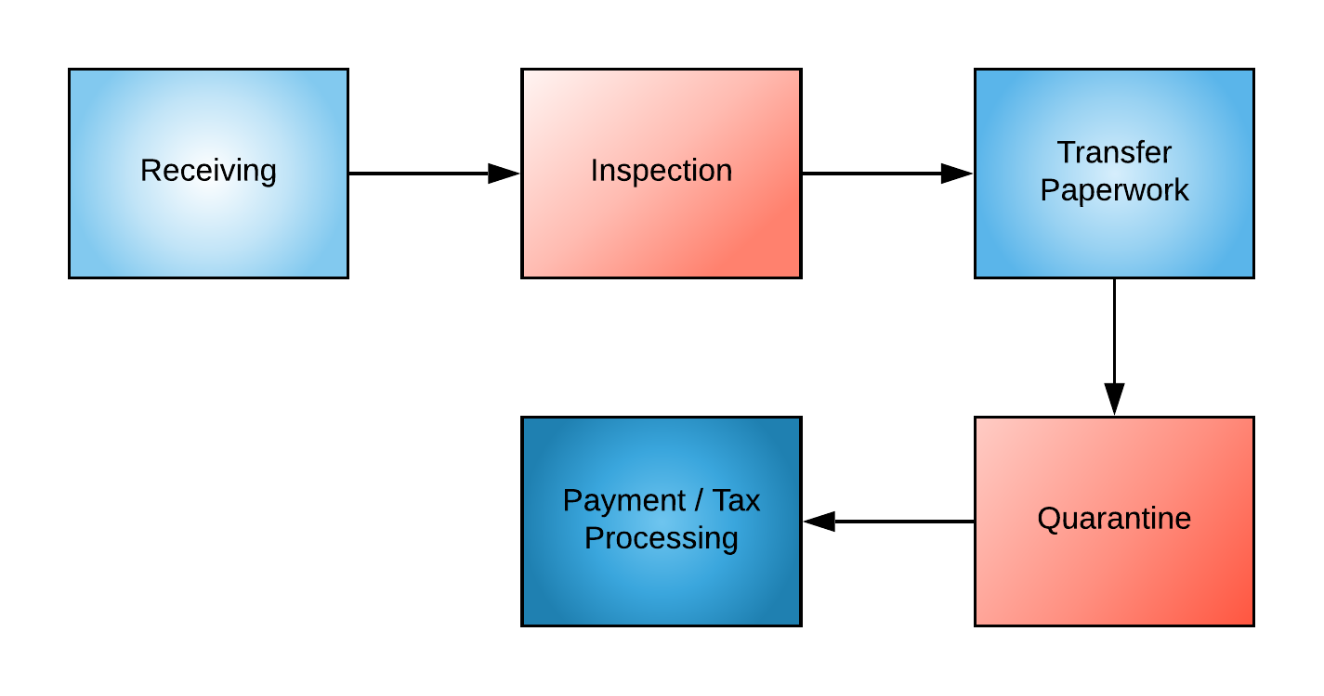

TRANSFER TO DISTRIBUTOR POLICY
The company is licensed as a microbusiness and as such will be primarily transferring product to its in-house distribution facility. All transfer procedures will be overseen by the Cultivation Operations Manager, who will, who will be responsible for setting the procedures for transferring product to the in-house distribution component in accordance with the mapped process. The operations manager may modify this process in accordance to the company policy for creating changes to the SOP manual which includes approval by the license holder. Any modifications will always also be checked against regulations and ordinances by the compliance manager to ensure consistent compliance.
The facility will carry out all harvesting activities in accordance with the above-referenced flowchart. A printable checklist with each individual step can be found at the end of this section.

TRANSFER TO DISTRIBUTOR PROCEDURE
Transfer activities at the facility will be carefully planned and indicated by the Cultivation Operations Manager, who will be responsible for creating orders or designating a trained staff to create orders as well as training and designating staff to prepare scheduled orders from facility inventory in accordance with company policies and procedures. Transfer staff will abide by all track and trace procedures found in the beginning of this operations section. Additional checklists for track and trace activities may also be found at the end of this section.
In addition to the above listed steps, all transfer-related activities will comply with the general sections found at the beginning of the CULTIVATION OPERATIONS section of this manual. A separate checklist of transfer activities that is guided by the process map will be found at the end of this section.

All the following general sections apply to activities undertaken during the process of transfer to distributor:

8000 Definitions

8106 Cultivation Plan Requirements

8403 Track-and-Trace System Unique Identifiers (UID)

Please note the following requirement for reference.

Section: 8214 Commercial Cannabis Activity Between Licensees
Cultivation licensees may conduct commercial cannabis activities with any other licensee, regardless of The facilities A or M designation of its license.

SECTION CHECKLISTS
In addition to specific standards for transferring cannabis that may be created and dispersed to employees of the facility, the following checklists may be printed and placed at workstations and/or with employees that must carry out the associated tasks.
Please note that this manual focuses on regulations associated with each process at your facility. Specific regulations that must be followed will be listed in the procedures section and will also be accompanied by a checklist. If only a basic checklist is shown, that means that only the general procedures and procedures created in-house by the facility and master grower apply.
If your company would like assistance building out policies and procedures for in-house standards, please reach out to Begreenlegal Cannabis Consultants for additional assistance in developing your internal standard operating procedures and training.

Transfer to Distributor Steps Checklist

q | Ensure items are received from the inventory to the transfer area and entered in track and trace
q | Ensure Packaging and labeling will be inspected for compliance
q | Ensure packages are properly prepared for shipment
q | Ensure that all manifests, delivery transcripts and other documents produced for the transfer are complete and attached to the shipment
q | Ensure that all packages intended for shipment are stored in the transfer area while awaiting transfer
q | Ensure that payment and processing has been completed and the transfer has been processed through track and trace

UID Track and Trace Checklist
q | Ensure all lots of immature plants are assigned a UID
q | Ensure UIDs are visible and within clear view of bystanders and free from dirt or debris
q | Ensure that lots are no more than 100 immature plants
q | Ensure that all plants in the lot are labeled with the corresponding UID lot number
q | Ensure that all plants in the lot are contiguous
q | Ensure that each immature plant intended for retail sale will have a UID affixed or be labeled with the corresponding UID number of the lot and be recorded in the track and trace system prior to transfer
q | Ensure that a UID is applied to all individual plants at the time any plant is moved or begins flowering (individual immature plants can be tagged prior to movement to designated canopy area or prior to flowering)
q | Ensure that UIDs are attached to each mature plat at the base of the main stem of each plant
q | Ensure that UIDs attached to mature plants are attached with a tamper evident strap or zip tie
q | Ensure that UIDs attached to mature plants kept free of dirt & debris
q | Ensure that UIDs attached to mature plants are in clear view of an individual standing next to them
q | Ensure that UIDs follow the mature plant and remain attached until the plant is harvested, destroyed or disposed
q | Ensure that a harvest batch name has been assigned to each harvest batch with a unique name that will be associated with all UIDs for each individual plant or portion of the plant from the batch
q | Ensure that the Harvest name remains associated with all cannabis from the batch through all modifications and derivations of the cannabis product after harvest
q | Ensure that UIDs from destructed or disposed cannabis or nonmanufactured cannabis products will be retired in the Track and Trace system within three days of destruction/disposal

Manufacturing Operations
There are two main areas of focus for all the operations of the facility. The first is compliance with all state regulations relating to each process. The second is the synergy of that compliance with a smooth and efficient process that produces manageable and repeatable results. As you may have noticed by going through the manual so far, each of our operations are broken down into a group of processes. In this section, we will break each process down for Manufacturing into policies and procedures that will tell you exactly what to do and when. Remember the steps indicated in the procedures are based not only on the company’s intended culture and work ethic, but also the regulations adopted by the City and the State. If at any time you feel that a procedure may need to be revised, speak to your Team Manager who will consider the request and activate the proper chain of activities to update the manual should a change be warranted.

Intake

POLICY
The Company will verify all licensed vendors from which it received product prior to ordering and scheduling the delivery of products to the facility. Deliveries will be scheduled such that routines and delivery times are not detectable due to subtle shifts and changes in the delivery schedule each time. It is the policy of the facility that a manager or manager’s designee be present to oversee the intake for all shipments. A minimum of two personnel will be present at each intake to ensure the safety of both staff and products at all times.
We anticipate receiving products to our distribution premises in one of two ways; either from our own cultivation operation via our cannabis storage, or from third-party cultivators and manufacturers who will either interact with our transporter at their location or drive their products to our distribution operation. All incoming cannabis materials of any kind will be associated with a Chain of Custody (COC) form and manifest.

INTAKE PROCEDURES
- Selection and verification of Vendors
- Scheduling of incoming products
- Onsite Verification procedures
- Security Check in
- Unloading and visual inspection
- Completion of Chain of transaction and Custody paperwork
- Release of transport driver
- Inventory and Storage of received product

Extraction

POLICY
Solventless extraction will be performed at the facility using a ___________ Rosin Pres extraction machine. Manufacturers instructions will be included in this policy and procedure manual or as an attachment when available and will be made available to all employees of the facility during and after orientation. It is the policy of the company to follow all prescribed instructions by the manufacturer first and foremost, in addition to complying with the regulated procedures outlined below.

SOLVENTLESS EXTRACTION PROCEDURES
- Receive Raw Material for pre-inspection
- Pre-Inspection Steps
- Preparation and Sifting of Raw Cannabis Material
- Storage of Prepared Cannabis Material
- Extraction of Raw Material – Rosin Press (Use Manufacturer Instructions where appropriate)
Extraction of Raw Material – Cold Water Extraction
- Quarantine of Extracted Materials
- Product Testing/Remediation
- Packaging & Labeling of Extracted Products
- Storage of Finished Cannabis Products for Distribution

Post Extraction

POLICY
Post extraction procedures will follow the step by step process outlined below. All post extraction activities will be performed in areas of the facility that have been cleaned and sanitized prior to use. Cleaning and sanitization procedures will be found in the Non-Laboratory Quality Control Procedures, Section VI. of this manual.

PROCEDURE
[TBD]

Infusion

POLICY
For the purposes of the Midnight Breeze facilities, infusion activities will be regarded as those which involve the infusion of concentrated cannabis into flower for pre-rolls or other similar infused products that may be brought to market. Bubble hash made in-house, rosin made in-house and bulk concentrate from other facilities may be utilized to complete this process. Each step of the process will be followed as noted in the procedure below.
PROCEDURE
- Receive extracted material or bulk concentrate
- Pre-Inspection
- Prepare material for infusion into pre-rolls
- Storage of prepared material in a secured location
- Infusion of pre-rolls using prepared recipes
- Quarantine of final products for pre-testing
- Testing/Remediation of Products
- Packaging & Labeling of Infused Cannabis Products
- Storage of finished products for distribution

Packaging and Labeling

POLICY
It is the policy of the company that all packaging and labeling activities will be performed in strict accordance with the procedures set forth below. All packaging and labeling areas will be in a clean and sanitized state prior to any packaging and labeling activities being performed. Instructions for any machines or equipment utilized for packaging will be included after this section of the manual and will be regarded above company procedures. State regulated procedures will always take precedence and should be in compliance with all manufacturer specifications.

PROCEDURE
- Receive raw cannabis material for pre-inspection
- Pre-Inspection procedure
- Prepare Raw Cannabis Material
- Quarantine Prepared Cannabis Material
- Test Material
- Package and label cannabis pre-rolls, vape cartridges, bulk concentrates
- Store finished cannabis products for distribution
- Transport/transfer product to distribution
Transport/Transfer to Distributor

POLICY
It is the policy of the company that transport procedures be followed in strict compliance with the steps set forth below. These steps have been developed in compliance with the state regulations for manufacturing licenses as well as those which regulate microbusinesses. Accurate tracking and tracing of all cannabis products stored for transport and transferred to the distributor is of the utmost importance and will be closely monitored by the manufacturing manager.

PROCEDURES FOR TRANSPORT/TRANSFER TO DISTRIBUTION
- Receiving
- Inspection
- Transfer Paperwork (Track & Trace)
- Payment/Tax Processing
- Quarantine

Relevant Code Sections: BCC/CCR:
8210 – Sample Collection by the Bureau

Distribution Operations
There are two main areas of focus for all the operations of the facility. The first is compliance with all state regulations relating to each process. The second is the synergy of that compliance with a smooth and efficient process that produces manageable and repeatable results. As you may have noticed by going through the manual so far, each of our operations are broken down into a group of processes. In this section, we will break each process down for Distribution into policies and procedures that will tell you exactly what to do and when. Remember the steps indicated in the procedures are based not only on the company’s intended culture and work ethic, but also the regulations adopted by the City and the State. If at any time you feel that a procedure may need to be revised, speak to your Team Manager who will consider the request and activate the proper chain of activities to update the manual should a change be warranted.

Pick-up Transport

[INSERT MAP/POLICY/PROCEDURE]

Receiving

[INSERT MAP/POLICY/PROCEDURE]

Packaging

[INSERT MAP/POLICY/PROCEDURE]

Testing Lab Engagement

[INSERT MAP/POLICY/PROCEDURE]

Shipping

[INSERT MAP/POLICY/PROCEDURE]

Delivery/Transport

[INSERT MAP/POLICY/PROCEDURE]

Waste Management
[CREATE MAP FOR PROCESS]

POLICY
Midnight Breeze, LLC has partnered with Green Waste Solutions to manage the waste for the entire microbusiness. Waste Management procedures are being addressed here separately as they will cover all three operations of the facility. The facility has an obligation to the state to properly handle all wastes in accordance with regulations both state and local. In partnering with a licensed waste management facility like Green Waste Solutions, we are setting up our facility to be in a continuous state of compliance with all waste management practices.
Please note that waste management must be handled by each operations team separately in the initial stages. This means that for each distinct set of activities, such as Cultivation, Manufacturing, and Distribution, there will be a unique set of procedures for handling each specific type of waste produced by those activities. Regardless of this, Green Waste Solutions will be handling all the waste types with one simple solution. Pickup can be scheduled quickly and reliably and will be handled in a discreet and compliant manner, leaving all required chain of custody paperwork in place.
For the purposes of this policy, Cannabis Waste will be considered as any material that is used for, or which comes into contact with cannabis during the cultivation, production, manufacturing , or distribution processes of the facility, and which must be disposed of. Examples are:
- Unused or leftover marijuana
- Expired, unused, or leftover edibles
- Unused or leftover oils or extracts
- Wrappings, cartridges, or products
- Cultivation trimmings
- Cultivation growing medium
- Used testing samples
- Harvested, used plants

WASTE MANAGEMENT PROCEDURES
- Green Waste Solutions will provide drums for each area of the facility operations that are adequate to contain a minimum of 2 weeks-worth of waste.
- Drum placement in designated areas
- Weighing and tracking of cannabis materials intended for disposal
- Rendering of cannabis materials into unusable and unrecognizable waste
- Scheduling of waste bin removal and replacement
- Disposal and Final Chain of Custody Paperwork
Quality Control Overview & Process Map
[INSERT PROCESS MAP]

BCC-LIC-017. Non-Laboratory Quality Control Policy

Objective
It is the Policy of The Company to maintain compliance with all local and state regulations including those referencing Non Laboratory Quality Control Procedures in the California Code of Regulations (CCR), speciﬁcally, Sections §5002, §5029, §5410, §5412 & §5424 and the Business and Professions Code (BPC) 26120 Subdivisions (c)(1)(A) and (c)(1)(B). Company Policy and Procedures address the compliant handling of product related quality control concerns addressed in the regulations. This form has been prepared to correspond with BCC-LIC-017 (New 10/18) Non Laboratory Quality Control Procedures.

Deﬁnitions
For the purposes of this policy, "Fresh Products" are deﬁned as those products which are considered to be recently harvested and which have an expiration at least four (4) months to twelve (12) months beyond the purchase date before expiration.

Non-Laboratory Quality Control Policy
The Manager(s) will follow the BCC-LIC-016. Inventory Procedures, Policy and Procedures to acquire Fresh Product that is not expired or near expiration. Fresh Products are to be insisted upon by the Purchasing manager to provide an adequate window of time move the entire product through the purchasing process. To ensure that purchased products are not made salable past their expiration date, the BCC-LIC-016. Inventory Policy and Procedure includes a check of product expiration dates on a bi-weekly schedule. Should the manager discover an expired product during the routine Inventory Reconciliation, the product will be logged and disposed of in accordance with Inventory Procedures, Steps 4 and 6, in compliance with CCR Section 5410.

It is the express Policy of The Company that all purchased inventory has been inspected and veriﬁed as being:

- From a licensed distributor
- Tested in accordance with all federal and state regulations
- Packaged in compliant and Child Resistant Packaging
- Properly labeled in accordance with the BPC Section 26120
- Determined as Fresh Product in accordance with this Policy

Required Information:
Business Name
Application Type
Primary Contact Name
Primary Contact Email
Primary Contact Phone Number

Packaging and Labeling Processes

Veriﬁcation of Label when Transferring Product

The manager will ensure proper veriﬁcation of labeled contents for cannabis goods batches when they are purchased from a licensed distributor and held in the secure storage on the premises, and any time a cannabis product moves from the secured storage through distribution of retail products, transfer to another licensee, expiration of product or additional reasons as determined by the manager. The manager will verify that any required information is written in English and is conspicuous and unobstructed in any way.

In accordance with Section 5412 of the California Code and BCC Regulations, all of the following will be visually and manually veriﬁed through BCC-LIC-017. Non Laboratory Quality Control Procedures, Step 1. Veriﬁcation will include:
- Authentication of distributor, manufacturer and/or cultivator name and license number via company ID and the shipping manifest in accordance with Step 2 of the BCC-LIC-016. Inventory Procedures, Acceptance of Inventory.
- Date of entry into storage area
- Recording of Unique Identiﬁers and batch number in accordance with BCC-LIC-016. Inventory Policy and Procedures
- Providing a complete description of the cannabis goods in the company POS or equivalent inventory tracking system
- Manual checking and recording the weight and/or quantity of units in the batch in the company POS or equivalent inventory tracking system
- Manual veriﬁcation and recording of expiration or sell-by date, if any, in the inventory tracking system

Final form of Veriﬁcation, Primary Panel Labeling and Informational Panel Labeling:

Label contents ﬁnal veriﬁcation for retail sale: If cannabis products will be distributed for retail sale, the manager preparing the order will utilize the checklist in Step 2 of the BCC-LIC-017. Non Laboratory Quality Control Procedures to perform a veriﬁcation of both the primary panel labeling and the informational panel labeling. Each label type must meet speciﬁc requirements under the California Code and BCC Regulations. These requirements include:
- Cannabis symbol imprint
- Licensed manufacturer and contact information
- Date of manufacture
- Listing of all product ingredients including information on food allergens
- Names of all artiﬁcial ingredients (if applicable)
- Nutrition Facts (if applicable)
- The product lot number
- Instructions for use
- Product expiration, "use by" or "best by" date
- The product UID

Veriﬁcation of Net Weight, Source and Date of Cultivation, Type of Cannabis, Date of Packaging, County of Origin, Allergens and UID:

In addition to the veriﬁcation procedure described above, the Operations Manager will also manually conﬁrm the presence of all of the following before transferring the product from secured storage to an authorized end user. All of the following information will be found in the company POS or equivalent inventory tracking system. A veriﬁcation checklist can be found in Step 3 of BCC-LIC-017. Non Laboratory Quality Control Procedures:
- Product net weight (if applicable)
- Identiﬁcation of the source and date of cultivation
- Identiﬁcation of the Cannabis Type
- Date of packaging
- County of Origin (if applicable)
- Allergen warning (if applicable)
- Unique track and trace identiﬁer (UID)

Veriﬁcation of Government Warning and Medical Use Label Requirements

The manager will verify that all government required warning labels that are applicable have been applied to the product before ﬁnal sale through the use of the checklist found in Step 4 of the BCC-LIC-017. Non Laboratory Quality Control Procedures. The manager will pay special attention to cannabis products that must include the label regarding medical use, in bold below, separating them from other products and performing a ﬁnal veriﬁcation to ensure proper labeling. Government warning labels include all of the following:

- “SCHEDULE I CONTROLLED SUBSTANCE"
- “KEEP OUT OF REACH OF CHILDREN AND ANIMALS” in bold print
- “FOR MEDICAL USE ONLY. ”
- “IF PREGNANT OR BREASTFEEDING, CONSULT A PHYSICIAN PRIOR TO USE.”
- “THE INTOXICATING EFFECTS OF THIS PRODUCT MAY BE DELAYED BY UP TO TWO HOURS.”
- “THIS PRODUCT MAY IMPAIR THE ABILITY TO DRIVE OR OPERATE MACHINERY, PLEASE USE EXTREME CAUTION.”

Veriﬁcation of Packaging Requirements:

The manager will verify through physical inspection that all of the following packaging requirements have been met. The veriﬁcation checklist can be found in Step 5 of the BCC- LIC-017. Non Laboratory Quality Control Procedures.
- Packages are free from contamination and have not been exposed to any toxic or harmful substances
- Packages have been placed in a container within which the product is sealed to prevent tampering
- Packages are certiﬁed Child Resistant
- Packages do not contain markings and do not imitate any packaging used in marketing to children
- If edible products are used, they are in opaque packaging
- Any package containing greater than one-serving is resealable

Preventative Maintenance: The manager will oversee the condition of stored cannabis goods onsite and will ensure that routine services such as pest control, do not disturb or penetrate the environment where cannabis goods are stored. The Company BCC-LIC-020. Delivery Policy and Procedures specify how managers will handle environmental controls. Regular maintenance and cleaning services are expected on the premises however, the manager will ensure that:
- If maintenance personnel is on site or must be in a secured storage area, they will be veriﬁed and authorized according to company security protocol, and accompanied by a manager at all times while on site
- Cleaning of the restricted access areas will be scheduled at regular intervals
- No cleaning chemicals or pesticides may be used in the vicinity of cannabis products
- Should an issue require chemical services, the manager will relocate cannabis product to an alternative restricted access area within the premises and engage security if necessary to secure the product until it is safe to return to the secured storage vault.

Product Returns: If a product is returned, the manager will log the product into the company POS or equivalent software. The manager will follow the checklist Step 5 of the BCC-LIC-016. Inventory Procedures for Logging Returned Cannabis. Returned cannabis products that have been logged will be placed in a secure receptacle for destruction and disposal in accordance with the BCC-LIC-016. Inventory Procedures Steps 5 & 6, and the BCC-LIC-019. Waste Management Procedures as they regard disposal and destruction of product.

Distributor License Storage Information Service to Other Licensees:

If the licensed facility is a distribution facility, and will provide storage-only services to other licensees, the Policy Manager will develop and implement a policy and procedure designating which licensees and license-types will be allowed storage-access, and which area(s) of the facility will be designated for storage-only services.

Storage in Limited-Access Areas:

Limited access areas of the premises are delineated on the Company Security Plan Site Map which is submitted with the license-application and will be retained on ﬁle with this manual. All limited and restricted-access areas are delineated and described on the Security Plan Site Map.

Storage and Separation of Cannabis Goods Batches for Testing

After taking physical possession of a cannabis goods batch, the distribution manager will comply with Section 5302 by following the BCC-LIC-017. Non Laboratory Quality Control Procedures to complete all of the following:
- Arrange laboratory testing through the company selected testing laboratory
- Separate products chosen for sampling into batches and place in a separate container
- Verify and log all products sampled for testing
- Physically attach a label to the container with the information outlined in the company procedure
- Move the batch of products to a designated area for storage and handling

Labeling and Packaging Procedures

When Labeling and Packaging Will Occur
Packaging and labeling of cannabis products can only occur if the distribution facility holds a manufacturing license. Retailers may not repackage or label any cannabis products. The regulatory provision for a distributor to package, re-package, label and re-label cannabis for retail sale is contingent upon the company's possession of a manufacturing license and work with its own products. If the licensee is a distributor, and does not possess a manufacturing license, no product labeling information will be changed except in the following case:

If it is determined during laboratory testing that a manufactured product is labeled with the incorrect amount of THC per package or serving but is within the THC limits for sale, the distributor may re-label the package with the accurate THC amount.

Area of Premises Designated for Packaging and Labeling

If a manufacturing license is held by the distribution facility, the labeling and packaging process will begin following completion or preparation of manufactured cannabis products in an area designated for packaging and labeling by the facility site plan.

Sampling Procedures for Distribution Activities

Testing Arrangements
After taking physical possession of cannabis goods batches, the manager will, at their earliest convenience, arrange for testing by the laboratory of choice at the ﬁrst available time that is amenable to the facility schedule. If it becomes necessary, the licensee and facility manager will determine a standard for the period between receipt of delivery and the call to schedule testing.

Sampling Procedures to Ensure Correct Batch Size and No Contact from Distribution Employees

The manager will follow the BCC-LIC-017. Non Laboratory Quality Control Procedures, Step 6 to ensure that the batch size from which the sample is taken meets the distribution requirements of Section 5305 of the California Code and BCC Regulations. The procedure has been created to ensure:
- Oversight and monitoring of laboratory personnel throughout the testing procedure
- Video surveillance and monitoring of all sampling activities (Video recordings will be maintained for a minimum of 180 days)
- Completion of Chain of Custody Form
- That facility managers or designees monitoring the sampling process will not assist or touch the cannabis goods or sampling equipment during the sampling process.

Video Recording of Sampling Activities

Sampling of cannabis goods batches will be conducted in a designated restricted access area of the building, such as a restricted access oﬃce which is equipped with video surveillance and monitoring equipment capable of facial recognition.

Chain of Custody Provided

The manager will verify that the laboratory has provided a copy of the required chain of custody form which contains the following minimum reporting requirements:
- Laboratory name, physical address, and license number
- Distributor name, physical address, and license number
- Microbusiness name, address and license number
- Unique sample identiﬁer
- Date and time of the sample collection
- Printed and signed name(s) of the sampler(s)
- Printed and signed name(s) of the testing laboratory employee that received the sample.

Per state regulations, the laboratory is required to provide updates to the chain of custody form each time one of the following events occur:
- The sample changes custody between license
- The sample is transported
- The sample is destroyed

Testing Results Procedures for Distribution Batch Testing

The testing laboratory will complete a Certiﬁcate of Analysis (COA) that is updated with testing results as follows, and remit the COA to the licensee:
- Quantitative results for each analyte must be reported using the appropriate units of measure as required under Chapter 6 of the BCC regulations
- Qualitative results for each analyte must indicate "pass" or "fail"
- Results for each test method must indicate “pass” or “fail”
- Results for analytes that were detected below the analytical method LOQ must indicate "<LOQ"
- Results for analytes that were not detected or detected below the LOD, must indicate “ND”
- Indicate "NT" for any test not performed by the laboratory

Failed Samples

It is the policy of The Company that failed samples will be handled in the following manner:
- The manager will log samples and the product batch in the company POS or equivalent inventory tracking system
- The licensee and manager will determine if the cannabis products meet requirements for remediation
- If no remediation is possible and the cannabis must be returned or destroyed, the manager will record the details of these decisions in the inventory tracking system
- Failed samples will be disposed of in accordance with the Company Waste Management Policy and Procedures and the Inventory procedures for logging, rendering and destruction of cannabis.
- The licensee and manager will determine whether remediation and retesting is possible. If remediation is possible, the manager will begin steps for remediation and retesting of cannabis products.

Passed Samples

Samples with a passing COA will be updated in the inventory tracking system and separated batches returned to the main cannabis storage area.

Track and Trace Procedures Following Testing

The Distribution manager will adhere to all Track and Trace reporting requirements for the logging of sample batches, destroyed cannabis products, and the return of samples with a passing COA in the state speciﬁed track and trace system.

Inventory Control Overview & Process Map
[INSERT PROCESS MAP]

BCC-LIC-016. Inventory Policy

Objective
It is the objective of this Policy to outline and describe all policies adopted by The Company with
regard to Inventory Procedures to maintain compliance with all state and local regulations. This
form has been prepared in specific compliance with BCC-LIC-016 Inventory Procedures (New
7/18)

Required Information
Business Name:
Application Type:
Policy Manager Contact Name:
Policy Manger Email:
Policy Manager Phone:

Considerations
            - The Manager will retain on file, a copy of the Security Diagram created with the licensing
application which indicates where cannabis goods will be stored on the licensed premises.
- Only the Licensee, Operating and Delivery Managers will have access to areas in which cannabis goods are stored.
- The premises will be outfitted with appropriate and compliant storage to maintain the security and safety of cannabis material. All cannabis products and any cash received will be kept in designated fireproof safes which will be located in restricted access areas throughout the facility. Only Licensees, Owners and management will be granted access to restricted areas. All restricted access areas will be outfitted with motion detectors, glass sensors, and surveillance cameras. The entire premises will be monitored and alarmed through the implementation of security equipment and devices included but not limited to:
  - A UL certified cellular communication burglar alarm with door contacts, motion detectors, safe contacts, and wireless panic buttons monitored remotely.
  - Electrified door locks and readers at key interior and restricted access locations
  - CCTV-2.1mp 1080p HD cameras with remote viewing from smartphone, tablet or desktop
- Cannabis goods will be stored indoors on the premises in a restricted access, climate controlled space. Controls for temperature will be accessible by owners, management and maintenance staff. Devices to control humidity will be utilized as determined necessary by the licensee and management.
- Managers will be trained on inventory procedures as determined necessary by the Licensee and Operations Manager. Cannabis goods may only be received by the Licensee or Facility manager unless otherwise determined and here updated by the Policy Manager. The manager will complete the training update form found in BCC-LIC-020. Delivery Procedures for each training and update and add the form to the employee's permanent file. Training will include all of the following:
  - A full review of Company Policies and Procedures related to inventory
  - Training on the State Track and Trace cannabis management system
  - Training on the company POS or equivalent inventory tracking system
  - Shadowing to provide sufficient oversight during the first 4 weeks of performing inventory related activities
  - Bi-monthly audits with the Facility Manager or Owner to ensure consistent inventory and compliance
- The following are the policies of The Company with regard to receiving shipments of cannabis goods inventory:
  - Managers will only accept inventory from a licensed distributor during operational hours of 6:00 AM PST to 10:00 PM PST.
  - During business hours, shipments will be allowed into the premises by a manager from an authorized entrance. If possible, the premises will allow for the receipt of deliveries at an area of the building that is not used for public access. If no such area is available, the manager will schedule deliveries at times when activities at the premises are more subdued such as early morning or mid-day.
  - It is the Policy of The Company that all shipments of cannabis goods are ordered by a manager from a verified licensed distributor. Only a manager can receive, count and pay for shipments.
  - The manager will receive the cannabis delivery into the authorized area where the transaction will be finalized. The manager will then release the delivery personnel into the reception area of the premises where they will be free to return to their vehicle. If security personnel are maintained on staff, the manager may request that the security personnel escort the transport driver to their vehicle. The delivery manager will transfer the cannabis into the restricted access storage area via handtruck, dolly or by hand-carry depending upon the size of the shipment and prepare it for entry into the inventory tracking system and stocking in the secured access area.
- Inventory will be documented upon receipt and upon movement from the premises by the manager in a company designated POS or equivalent tracking system. Records that are produced and maintained regarding the movement of inventory include receipt of inventory and sale of inventory records as noted below:

Documentation of Receipt of Inventory - Records Produced
It is the Policy of The Company that an updated Business Inventory is kept on the premises at all times and will be made available to the Bureau of Cannabis Control at their request. Inventory records will be maintained in the company designated POS or equivalent tracking system. The following items are required as a part of The Company inventory:

- A description of each item in the inventory, this description will be such that the cannabis goods can easily be identified;
  - The item's Unique track and trace identifier if applicable
  - An accurate measurement of the quantity of each item;
  - The date and time the cannabis goods were received by the Manager;
  - The sell-by or expiration date on any cannabis goods, if any;
  - The name and license number of the licensee that delivered the cannabis goods to the licensed premises;
  - The name and license number of the distributor that provided the cannabis goods to the licensed business;
  - The price paid for the cannabis goods, including taxes, delivery costs, or any other associated costs

Documentation of Sales - Records Produced
It is the policy of The Company that sales will only be received and recorded by a Manager. All records of sales will be made available to the Bureau of Cannabis Control upon request. Inventory will be recorded within the company designated inventory or POS system. Records will include all of the following:

  - The name and employee ID of the manager who processed the sale
  - The first name of the customer and POS generated customer ID if applicable
  - The date and time of the transaction
  - A list of all cannabis goods purchased including unique track and trace identifiers if applicable
  - The total amount paid for the sale, including individual prices paid for each cannabis product purchased and the associated taxes for each sale.
- All cannabis goods removed from the inventory will follow the documentation guidelines noted above and the resulting records will be recorded in the company POS or equivalent inventory tracking system before products are moved from secured inventory storage. Product orders will be retrieved and logged by management staff only, prior to preparation for delivery. Cannabis goods will be removed from inventory only by the management or licensee for the following reasons:
  - Sale of inventory - order preparation
  - Expired product
  - Inspection of product
  - Other reasons that may be determined only by the licensee

Once cannabis goods have been selected, logged and prepared either for delivery, inspection or destruction, the manager will do one of the following:
- For inspection, the item(s) will be inspected per requirements and returned to the restricted access storage area.
- If items have been designated for destruction due to return of product, expired product or a failed inspection (contaminated product), the manager will follow the Policy for procedures for Significant Discrepancy found in #10 below and in the BCC-LIC-016. Inventory Procedures document that accompanies this policy.
- If cannabis items have been selected, logged and packaged for delivery, the packages will be held in the secured storage space until a delivery employee is available for receipt of the items for delivery. The manager will transfer delivery items to drivers in accordance with the Company BCC-LIC-020. Delivery Policies and Procedures.
- The Licensee and facility manager will make determinations as to the best the temperature and humidity settings in the secured cannabis storage areas and post the preferred climate conditions near the climate controls for the secured storage space. The facility manager will perform daily checks to ensure that climate conditions are maintained in accordance with the preferred settings.
- It is the policy of The Company that an inventory inspection and reconciliation will be performed by a manager, every two weeks, with the highest level representative of the company present (such as Licensee, COO, or CEO). The Licensee, COO or CEO will provide inventory training to the manager at the beginning of employment and on an as needed basis in the course of their concurrent reconciliations. Records produced during inspection will include verification of a manual count of each item followed by reconciliation to the expected inventory count. This inspection will be performed in compliance Section 5034 of the California Code and Bureau of Cannabis Control (BCC) Regulations.
- This policy will be reviewed and updated by the Policy Manager at intervals of no less than six months.
Security Overview & Security/Premises Diagram(s)
CC-LIC-018. Security Policy

Objective
It is the objective of this Policy to outline and describe all policies adopted by The Company with regard to Security Procedures in order to maintain compliance with all state and local regulations. This form has been prepared in speciﬁc compliance with BCC-LIC-018. Security Procedures (New 10/18) and in compliance with The Company Security Plan.

The Company Security Policy, Procedures and Security plan are prepared in compliance with the California Code of Regulations and the Bureau of Cannabis Control Regulations including form BCC-LIC-018, Security Procedures and all applicable regulations of the operator license including provisions for CCR, Article 5. Security Measures.

Required Information

Business Name:
Application Type:

Primary Contact Name:

Primary Contact Email:

Primary Contact Phone Number:

Considerations
Security Operating Procedures speciﬁc to the licensed premises will be developed by a licensed security ﬁrm selected by the applicant during the application process for licensing. The security ﬁrm will be licensed in accordance with the California Department of Consumer Aﬀairs, Bureau of Security and Investigative Services, Business and Professions Codes for Private and Proprietary Security Services.
The licensed operator will select a Security Manager or Designated Security Representative who will be responsible for the implementation of the facility Security Plan, and who will complete all procedures related to company security, including notifying the City designee within twenty-four (24) hours of discovering a signiﬁcant inventory discrepancy whether through the reconciliation of inventory or the detection of diversion, theft, loss, or any criminal activity by any agent or employee of the operation. The Security Manager will oversee all Security Personnel of the facility. Speciﬁc job duties for each description are as follows:

Security Manager: The Security Manager will work with the GM to implement the Security plan commissioned by the Board of Directors. This professional will have proven management skills and be expertly trained in all aspects of Security and leadership. Preference will be given to applicants whose background includes experience in the cannabis or related industries. Our Security Manager will be responsible for interviewing and training security personnel and developing the culture of friendly, ﬁrm and responsible management of the premises exterior and interior.

This manager will schedule all security needs and will ensure coverage at all times by a consistently monitored and active surveillance and security system. They will also be responsible for developing and implementing a proven veriﬁcation system to ensure that only authorized visitors will be served on the premises. This position will work with outside security monitoring personnel and agencies to ensure complete and consistent coverage in all situations, and to maintain strict compliance with all regulations existing and new. Security surveillance records will be maintained by this manager for a minimum of 90 days and will be produced upon request of authorized enforcement personnel.
Security Personnel: Security personnel will have a minimum background in security services with a preference given to those who have secured cannabis retail operations with proven results.

Security Team (in-house trained staff): This team of staff will work together to achieve a total awareness of the premises at all times. A team hierarchy will be in place, with several members in communication with the Security Manager throughout the day. They will be trained to manage a variety of situations including but not limited to: robbery, harassment, parking congestion, removal of intoxicated or uncooperative persons, safety of inventory and attendance to the security of customers entering and exiting the premises. The culture of the security personnel will be a team in constant communication and vigilance of the safety of all on the premises, and this culture will be developed and supported by the Security Manger.
The licensee will ensure that during the application process, additional points will be added to this section to include a description of all entrances and exits, windows and doorways of the facility:

Security of Entrances and Exits, Windows and Doorways

While the creation of a defensible perimeter increases the resiliency of security measures that can reduce outside threats, the implementation of counter measures on the interior of the facility has a supportive eﬀect in reducing risks of theft or diversion from internal threats. The following will apply to all windows and doors of the facility:
- All windows will be rendered inoperable or locked and covered by frosted glass or similar acceptable product with at least 50% transparency to prevent clear viewing in the to the interior of the facility.
- All windows will be upgraded with impact and forced entry resistant window ﬁlm and/or steel welded interior bars to prohibit forced entry.
- The suite will be separated into workﬂow areas that support the processes intended for the facility. All entry and access points, such as windows, will be monitored via secured technology including but not limited to, sensors, alarms, locks and video surveillance in all sensitive-task, and restricted-access areas.
INCLUDE A DESCRIPTION OF THE MAIN ENTRANCES AND EXITS OF THE FACILITY
INCLUDE A DESCRIPTION OF EMERGENCY EXITS AND RESTRICTED ACCESS AREAS OF THE FACILITY
INCLUDE A DESCRIPTION OF SECURITY DOORS, LOADING AND ROLLUP DOORS, OR OTHER SIMILAR LOADING AREAS OF THE FACILITY

Access to the premises will be regulated by the facility Security Plan and implemented by the Security Manager in all of the following ways:

List of Security Employees: The licensee will ensure that upon fully staﬃng the licensed location, a complete list of employees with security access, including their roles and responsibilities whether as Security Manager or Security Personnel, will be included with this security Policy. The list may be entered in the space below, attached to this Policy in a physical manual, or kept in a secured record or ﬁle by the Security Manager, the location of which should be here referenced. The list of employees who have access to the security system will be managed by the Security Manager and made available upon request by the BCC or other authorized regulatory agencies.

Access Control: Access control systems are designed to monitor entries and exits and grant secure entry into restricted access areas of the facility. The design, equipment and placement of the security system will be carefully considered under the expertise of cannabis security consultants to ensure secured and compliant premises.

The entire premises will be monitored and alarmed through the implementation of security equipment and devices including but not limited to:
- A UL certiﬁed cellular communication burglar alarm with door contacts, motion detectors, safe contacts, and wireless panic buttons which will be remotely monitored;
- Electriﬁed door locks and readers and key interior and restricted access locations;
- CCTV – 2.1mp 1080p HD cameras with remote viewing from smartphone, tablet or desktop

Recording of Visitors in Conformance With Section 5042 of the BCC Regulations:
- Only individuals twenty-one (21) years and older are permitted on the property
- All visitors will be veriﬁed via secure ID check and be recorded in the visitor log which records both the arrival and departure time of all authorized visitors to the facility.
- Visitors will be given a badge to indicate they have been veriﬁed, and will be escorted by a manager at all times while on the premises
- All visitors, including employees, will be required to check in to a security oﬃce through a secured access oﬃce or lobby.

[To be completed when staﬃng for the licensed premises has been secured]
The list of security personnel along with their roles and responsibilities is as follows: [INSERT]

Employee and Badge Requirements, in compliance with Section 5043 of the BCC Regulations:

- The Licensee will only employ individuals over the age of 21
- Employees will be granted access to the facility through secured keycards and badges which will be returned upon termination or resignation
- Each employee badge will contain a unique employee number, which will be retired permanently when the employee ﬁle is closed
- Employees may acquire additional access to restricted areas of the facility if they are promoted within the employment hierarchy. If an employee gains additional access to the facility, this access will be accompanied by employee review documentation and the assignment of a new employee badge and number which will be maintained in the company's employee ﬁle
- Returned company badges and key fobs contain card reader software that will allow the implement to be reset with a new number and appropriate access. The Security Manager will work closely with the Operations Manager to ensure a smooth rotation of clean secured badges and key fobs as needed.
- Designated storage areas, break rooms, changing facilities and bathrooms will be provided by the licensed premises and separated from any storage area or space where cannabis is handled.
- Licensees will only employ eligible and authorized personnel in compliance with all State and Local ordinances

The video surveillance system will be designed and monitored by a licensed ﬁrm. The system will include all of the following:

Types of Camera and Video Storage Equipment

The CCTV system will be designed to support and compliment the visually monitored perimeter which defends against and documents intrusions, diversion and theft. The interior of the facility will be additionally improved to provide continuous coverage of individuals handling cannabis and related products. Any security hardware will be closely monitored and speedily serviced, repaired or replaced in the event of hardware failure. The system will be designed to include all of the following speciﬁcations:
- Cameras will have permanent day/night infrared capability
- Individual cameras will have a minimum resolution of 1280x720 pixels and will record continuously 24/7 at a minimum of 15 frames per second with recordings kept on ﬁle for a minimum of 90 days
- A minimum of 3 days recordings will be backed up to a secured cloud or other oﬀ-site location
- The system will be transmission control protocol (TCP) capable and accessible through the internet
- Each authorized user will have individual credentials and remote access to the system
- All camera hardware will be tampering and vandal resistant
- A Network Video Recorder (NVR) will have the ability to download and generate DVDs/
- ﬂash drives of CCTV footage as well as print still images via a nearby printer
- The NVR will use a failure notiﬁcation system to alert the licensee of an interruption in the video surveillance
- A backup generator or battery suﬃcient to power the CCTV system for four hours will be linked to the NVR
- The system will maintain an accurate date/time stamp in compliance with the US National Institute Standards and Industry Technology Standards.
- The NVR for each premises will be separated in a high-level restricted access area to prevent tampering or theft

Description of Camera Placements and Number of Cameras to be Used

The licensee, at the time of application, will hire a licensed security ﬁrm to assist in designing the appropriate security program for the operating facility. At that time, the licensee and the security ﬁrm will determine the placement of all interior and exterior CCTV equipment and record the placement on the Security Diagram Map. The completed Security Diagram Map will either be attached to or described in this policy. In addition:

- Camera placement will cover areas that are no more than 20 feet from where cannabis and related products are handled, transported, manipulated or stored.

Procedures for Maintenance of the Video Surveillance Equipment

The CCTV Equipment will be maintained and repaired by the security monitoring facility. The licensed security ﬁrm will be notiﬁed within 4 hours of the necessary repair or replacement by the Security Manager or a Designee

The Security Manager will designate security equipment and maintenance checks for security personnel through the use of the Company form BCC-LIC-018. Security Procedures.

Notiﬁcation of Video Surveillance System Failure or Malfunction

A Network Video Recorder (NVR) will be installed in the security oﬃce at the licensed premises
The NVR will use a failure notiﬁcation system to alert the licensee of an interruption in the video surveillance

Monitoring of the Video Surveillance Equipment

The video surveillance equipment will be monitored in a central security oﬃce on the premises. The Security Manager or designee will continuously monitor the security oﬃce and monitors throughout the day at regular intervals determined by the Operations and Security Manager.

The Security Manager may utilize the monitoring check form found within the steps of the company form BCC-LIC-018. Security Procedures to record the activities of designated security personnel monitoring the equipment if desired

Production of Recordings for the Bureau

- A Network Video Recorder (NVR) will be installed in the security oﬃce at the licensed premises
- The Network Video Recorder (NVR) will have the ability to download and generate DVDs/ ﬂash drives of CCTV footage as well as print still images via a nearby printer for immediate production of recordings in response to a request from the BCC

At the time of application, the licensee will determine whether security personnel will be employed by or contracted by the applicant and complete the sections below.

Security Contracts
If security personnel is contracted by the licensee, this record will be updated with the name of the security company, the license number, contact person and phone number of personnel that will be providing services.
If security services are contracted, the licensee will attach a copy of the contract to this policy.

Location of Security Personnel on the Premises

This section will be completed with information from the Final Security Plan for the completely designed licensed facility

Hours Security Personnel will be onsite

This section will be completed with information from the Final Security Plan for the completely designed licensed facility

Sharing Personnel with Other Licensees

If the applicant will be sharing security personnel services at the licensed premises with another licensee at the same location, a description will be provided here as to how the facilities will share the services and the cost of the services. If the applicant will not be sharing security services, this item is considered not applicable to this security policy.

Armed or Unarmed

The licensee and security ﬁrm will determine the needs of the facility at the time of completion of the Final Security Plan. The Final Security Plan will determine whether armed or unarmed security guards will be utilized at the premises. When the plan is ﬁnalized, the licensee will complete this section with relevant information from the Final Security Plan.

Security Alarm System:
The building alarm system will be designed in accordance with the needs of the future tenant(s) to establish an electronically monitored perimeter that defends and alerts against intrusion. Interior contact points and motion sensors will alert a designated California Bureau of Security and Investigative Services contracted alarm service of unauthorized access. The system will be designed to the following speciﬁcations:

Security Alarm System Contact Information
Once the contract is secured, the security alarm contact information will be recorded below in this section and will include the company name, license number, address, phone number and contact person of the alarm company that installed, maintains and monitors the alarm system.

Alarm Operations and Maintenance
- Alarm system monitoring and access will be continuous and available to operators 24/7.
- The licensed premises will be monitored by a licensed alarm company for motion sensors, door/window contact point triggers, glass break sensors, C02 sensors, ﬁre/smoke alarms, panic buttons, and keypad duress codes.
- Security codes held by the operator and designees will secure the alarm from inside of the premises.
- Daily maintenance checks will be performed by onsite security personnel.
- Maintenance checks by the licensed alarm company will be provided no less than quarterly.

Description of Alarm Features

- Alarm system monitoring and access will be available to operators 24/7.
- The licensed premises will be monitored by a licensed alarm company for motion sensors, door/window contact point triggers, glass break sensors, C02 sensors, ﬁre/smoke alarms, panic buttons, and keypad duress codes. Additional details may be added upon ﬁnalization of the facility Security Plan.
- Building safety systems and ﬁre, C02 and smoke alarms will be approved by the appropriate certifying entity in accordance with best practices, statutory compliance and a ﬁre safety plan.
- The proposed building alarm system achieves City standards for UL Certiﬁcation in accordance with ANSI/UL Standard 681-2014 (Standard for Installation and Classiﬁcation of Burglar and Holdup Alarm). The holdup alarm system will be employed near the transportation areas, lobby, employee entrance, and in all restricted access oﬃces where product safes will be located.
- The burglar alarm will cause dispatch through the operator’s chosen security contractor. A holdup alarm will cause the dispatch of the local Police Department. The facility will employ the use of a generator or battery pack to ensure that security systems will operate for at least 24 hours of continued operation time in case of a power failure. In case our security system is not able to function, the operator will staﬀ the facility 24 hours per day until the security system is again functional.
- The alarm system will be accessed by only authorized users with unique access codes maintained by the alarm company. The access codes will be assigned to employees or security personnel of the company. Upon arming or disarming the system, the unique codes will be recorded by the alarm system and a record maintained with notiﬁcations when the alarm system was armed and disarmed, and by whom.

Response Procedures

- The burglar alarm will cause dispatch through the operator’s chosen security contractor. A holdup alarm will cause the dispatch of the local Police Department. The facility will employ the use of a generator or battery pack to ensure that security systems will operate for at least 24 hours of continued operation time in case of a power failure. In case the security system is not able to function, the operator will staﬀ the facility 24 hours per day until the security system is again functional.
- In cases of an armed robbery and as a preventative training, each employee will be trained to follow The Company Armed Robbery and Prevention and Procedures upon orientation as an employee of The Company.
- Additional operations procedures may be added at the ﬁnalization of the Security Plan

Sharing the Alarm System With Other Licensees

If the security alarm system will be shared by more than one licensed premises, the parameters of the agreement will be determined by the Final Security Plan and added to this section. If the alarm system is utilized by only one licensed premises, this section will be considered not applicable.

Safety Overview & Process Map
[MODIFY STANDARD SAFETY MANUAL AND INSERT HERE]

